**Career Compass: A path Finder Application for Students and Youngsters**

Career Compass is an innovative React-based web application designed to guide students in making informed career choices. Leveraging data-driven insights, the application offers personalized course and exam recommendations based on the user's age, gender, and educational qualifications. The platform features two main components: the Course Form and the Education Form. The Course Form gathers essential user information, such as name, age, sex, and educational background, and filters data from a pre-processed JSON dataset to provide customized course suggestions. The Education Form focuses on filtering exam details, considering both age and qualifications to inform students about relevant entrance exams, certifications, and other assessments. The data used by Career Compass is meticulously organized and pre-processed to eliminate duplicates, errors, and noise, ensuring the accuracy and reliability of the information provided. By tailoring these recommendations, Career Compass simplifies the decision-making process for students, helping them navigate the vast landscape of educational and career opportunities. This application is particularly valuable for students at various stages of their academic journey, offering a comprehensive and user-friendly solution to explore and pursue their desired career paths effectively.

**TABLE OF CONTENTS**

|  |  |  |
| --- | --- | --- |
| **C. NO** | **TITLE** | **PAGE NO** |
|  | **ABSTRACT** | **I** |
| **1** | **INTRODUCTION** |  |
|  | 1.1. Overview |  |
|  | 1.2. Problem Definition |  |
|  | 1.3. Objective of the Project |  |
|  | 1.4. Scope of the Project |  |
| **2** | **SYSTEM SPECIFICATION** |  |
|  | 2.1. Hardware Requirements |  |
|  | 2.2. Software Requirements |  |
| **3** | **SYSTEM ANALYSIS** |  |
|  | 3.1. Existing System |  |
|  | 3.2. Proposed System |  |
| **4** | **SOFTWARE DESCRIPTION** |  |
|  | 4.1. React.js |  |
|  | 4.2. MongoDB |  |
|  | 4.3. Node.js |  |
|  | 4.4. Express.js |  |
| **5** | **SYSTEM DESIGN** |  |
|  | 5.1. Data Flow Diagram |  |
|  | 5.2. Entity Relation Diagram |  |
|  | 5.3. Use Case Diagram |  |
|  | 5.4. Sequence Diagram |  |
| **6** | **SYSTEM IMPLEMENTATION** |  |
|  | 6.1. System Description |  |
|  | 6.2. System Flow |  |
| **7** | **APPENDIX** |  |
|  | 7.1. Source Code |  |
|  | 7.2. Screenshots |  |
| **8** | **CONCLUSION** |  |
|  | 8.1. Conclusion |  |
|  | 8.2. Future Enhancement |  |

**CHAPTER 1**

**INTRODUCTION**

**1.1. OVERVIEW**

Career Compass is a cutting-edge web application developed using React, aimed at guiding students toward making informed decisions about their educational and career paths. It provides a user-friendly platform that leverages personalized recommendations based on key user data such as age, gender, and educational qualifications. The application is structured around two main components: the Course Form and the Education Form, each serving a distinct purpose in the guidance process.

The **Course Form** is designed to collect basic information from the user, including their name, age, sex, and educational background. Once the user inputs their details, the application filters through a meticulously organized and pre-processed JSON dataset. This dataset is curated to ensure that it is free from duplicates, errors, and noise, thus guaranteeing the reliability and accuracy of the information provided. Based on the user's educational qualifications, Career Compass generates a list of relevant course suggestions. These recommendations are tailored to align with the user's background and interests, helping them explore suitable academic and professional options. The aim is to streamline the process of discovering courses that can enhance the user's skills and career prospects.

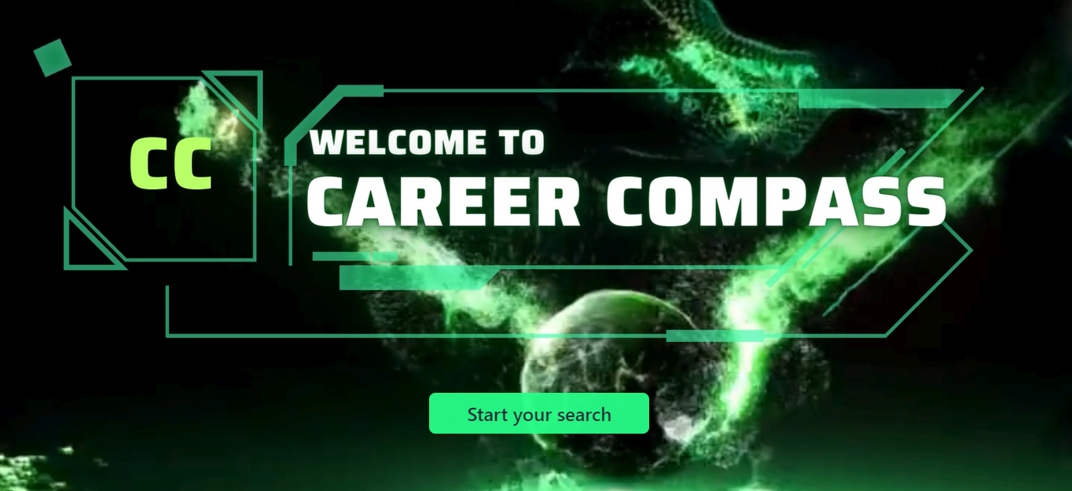

The **Education Form** focuses on providing detailed information about exams. This component takes into account the user's age and qualifications to offer insights into relevant entrance exams, certifications, and other assessments. The form filters data to present exams that are crucial for advancing in the user's chosen field. By doing so, Career Compass ensures that students are well-informed about the necessary steps they need to take to achieve their career goals. Whether it is preparing for competitive exams, professional certifications, or other essential assessments, the application provides comprehensive guidance to help students succeed.

One of the key strengths of Career Compass is its commitment to data accuracy and reliability. The application employs rigorous data preprocessing techniques to eliminate any duplicates, errors, or noise from its datasets. This meticulous attention to data quality ensures that the course and exam information provided is not only relevant but also trustworthy. As a result, users can rely on the application to make well-informed decisions about their educational and career paths.

**1.2. PROBLEM STATEMENT**

The existing career guidance systems lack a comprehensive and reliable approach to organizing and presenting data that helps students make informed decisions about their educational and career paths. These systems often suffer from issues such as outdated or incomplete information, unprocessed datasets containing duplicates, errors, and noise, and a lack of personalized recommendations tailored to individual student profiles. As a result, students are left without the necessary tools to navigate the complex landscape of academic and professional opportunities effectively. There is a pressing need for a solution that offers organized, accurate, and reliable data, along with personalized guidance, to empower students in making well-informed decisions about their future careers.

**1.3. AIM AND OBJECTIVE**

**Aim**

The aim of Career Compass is to provide students with a reliable and comprehensive platform that offers personalized guidance for making informed decisions about their educational and career paths. By leveraging meticulously organized and pre-processed data, the application seeks to eliminate the challenges associated with unreliable and disorganized information found in existing career guidance systems. Career Compass aims to deliver accurate course and exam recommendations tailored to the individual profiles of students, thereby empowering them to confidently explore and pursue suitable academic and professional opportunities. Ultimately, the goal is to simplify the decision-making process for students, helping them achieve their long-term career aspirations with clarity and confidence.

**Objectives**

* To provide students with personalized course recommendations based on their educational qualifications, age, and interests.
* To offer detailed information on relevant exams, including entrance tests and certifications, tailored to students' academic profiles.
* To ensure data accuracy by using pre-processed datasets free of duplicates, errors, and noise.
* To streamline the process of exploring educational and career options by organizing information in an accessible and user-friendly manner.
* To bridge the gap between students' academic background and potential career paths through data-driven insights.
* To enhance students' understanding of the steps required for specific career paths, including necessary exams and qualifications.
* To provide a reliable platform that addresses the shortcomings of existing career guidance systems.
* To support students at various stages of their academic journey with relevant and timely information.
* To empower students to make well-informed decisions about their future education and career choices.
* To create a comprehensive tool that assists students in planning and achieving their long-term career goals.

**1.5. SCOPE OF THE PROJECT**

The Career Compass project aims to create a comprehensive and user-friendly web application designed to assist students in navigating their educational and career choices. The scope of the project includes several key aspects:

1. **User Profile Management**: The application will capture essential user details such as name, age, sex, and educational qualifications. This data will form the basis for generating personalized recommendations.
2. **Data Processing and Management**: The project will involve the collection, organization, and preprocessing of data related to courses and exams. This includes ensuring the data is accurate, up-to-date, and free from duplicates, errors, or noise.
3. **Course Recommendations**: Based on the user's educational qualifications, the system will provide tailored course recommendations, helping students identify relevant academic and professional options.
4. **Exam Information**: The application will also provide detailed information on relevant exams, including entrance tests, certifications, and other assessments necessary for pursuing specific career paths.
5. **User Interface and Experience**: The project will focus on developing an intuitive and accessible user interface, ensuring a seamless experience for students as they explore their options.
6. **Data Security and Privacy**: Ensuring the security and privacy of user data will be a critical aspect of the project, adhering to best practices and regulations.
7. **Scalability and Flexibility**: The application will be designed to accommodate a growing number of users and data, with the potential to expand to include more educational and career-related information.
8. **Integration with External Resources**: There is potential for integrating external resources, such as educational institutions, career counseling services, and job portals, to provide a more comprehensive view of career opportunities.
9. **Continuous Improvement and Updates**: The project scope includes provisions for regular updates and improvements based on user feedback, changes in the educational landscape, and technological advancements.
10. **Evaluation and Testing**: Rigorous testing and evaluation processes will be implemented to ensure the accuracy and reliability of the recommendations provided by the system.

**CHAPTER 2**

**SYSTEM SPECIFICATION**

**2.1. HARDWARE REQUIREMENTS**

* **Processor**  : Intel® Core™ i5 processor
* **RAM**  : 8GB
* **Hard disk**  : 500 GB

**2.2. SOFTWARE REQUIREMENTS**

* **Programming** : React.js, Node.js, Express.js.
* **Database**  : Mongo DB
* **Operating System** : Windows 10 or 11
* **System type**  : 32 or 64 Bit OS
* **IDE**  : Visual Studio Code.
* **Packages**  : Material UI, Tailwind CSS

**CHAPTER 3**

**SYSTEM ANALYSIS**

**3.1. EXISTING SYSTEM**

The current landscape of career guidance systems primarily consists of traditional counseling, static websites, and basic online tools that offer general information on courses and career paths. These systems are often not tailored to individual needs and lack the technological sophistication to provide personalized recommendations. Traditional career counseling, while valuable, is limited by accessibility, as it typically requires in-person sessions and can be costly. Many online platforms provide a vast amount of information, but they often present it in a disorganized and overwhelming manner, making it difficult for users to navigate and find relevant data.

These existing systems also tend to rely on outdated databases that do not reflect the latest developments in education and job markets. Additionally, they often lack integration with the latest technological advancements, such as data analytics and machine learning, which could enhance the personalization and accuracy of their guidance. Consequently, students are often left with generic advice that does not consider their unique backgrounds, qualifications, and career aspirations.

**3.1.1. DISAVANTAGES**

* **Lack of Personalization**: The existing systems often fail to provide personalized guidance, offering generic advice instead.
* **Outdated Information**: Many platforms use outdated databases, which do not reflect current educational and job market trends.
* **Accessibility Issues**: Traditional counseling can be expensive and requires physical presence, making it less accessible.
* **Data Organization**: Information is often presented in a disorganized manner, making it difficult for users to find relevant data.
* **Limited Scope**: Existing tools typically offer limited scope, covering only basic information without in-depth insights.
* **No Real-Time Updates**: These systems lack real-time data updates, which are crucial for providing accurate guidance.
* **Lack of Integration**: There is often a lack of integration with external resources, such as educational institutions or job portals.
* **High Cost**: Traditional counseling and some online platforms can be costly, limiting access for many students.
* **Limited User Interaction**: Existing systems often do not allow for interactive experiences or user feedback, limiting engagement.
* **Inconsistent Quality**: The quality of advice and information can vary widely, leading to inconsistent user experiences.

**3.2. PROPOSED SYSTEM**

The proposed Career Compass system is a modern web application designed to provide students with personalized, reliable, and comprehensive career guidance. By leveraging advanced technologies such as data analytics and machine learning, Career Compass aims to address the limitations of existing systems and offer tailored recommendations based on user profiles. The system features two main components: the Course Form and the Education Form, which together create a holistic approach to career planning.

* Personalized Recommendations: Career Compass provides customized course and exam suggestions based on the user's age, gender, and educational qualifications. This personalization ensures that recommendations are relevant and specific to each user’s background and interests.
* Accurate and Up-to-Date Data: The system uses meticulously curated and pre-processed datasets, eliminating duplicates, errors, and noise to ensure the reliability and accuracy of the information provided.
* User-Friendly Interface: The application is designed with an intuitive interface that makes it easy for users to input their data and navigate through recommendations and information.
* Real-Time Data Updates: Career Compass incorporates real-time data updates, ensuring that users have access to the latest information on courses, exams, and career opportunities.
* Comprehensive Coverage: The system offers a broad range of data, covering various educational and career paths, including detailed information on relevant exams and certifications.
* Enhanced Accessibility: As a web-based platform, Career Compass is accessible to users from anywhere, at any time, without the need for physical visits or costly consultations.
* Integration with External Resources: The system can be integrated with educational institutions, job portals, and career counseling services to provide a more comprehensive view of career opportunities.
* Interactive Experience: Users can interact with the system to refine their preferences and receive updated recommendations based on their evolving needs.
* Cost-Effective: Career Compass provides valuable career guidance at a lower cost compared to traditional counseling services, making it more accessible to a broader audience.
* Consistent Quality: By utilizing advanced technologies and maintaining high data standards, Career Compass ensures a consistent and high-quality user experience, offering reliable and actionable insights.

**3.2.1. Benefits of the Proposed System**

1. **Tailored Guidance**: Provides personalized recommendations that are relevant to each user's specific background and goals.
2. **Reliable Data**: Ensures accuracy with pre-processed, high-quality data.
3. **User-Friendly**: Offers an intuitive and easy-to-navigate interface.
4. **Real-Time Updates**: Keeps users informed with the latest information.
5. **Broad Scope**: Covers a wide range of educational and career opportunities.
6. **Accessible**: Available online, removing barriers to access.
7. **Integration Capabilities**: Links with external resources for comprehensive guidance.
8. **Interactive**: Allows for user engagement and feedback.
9. **Cost-Effective**: Offers a more affordable alternative to traditional counseling.
10. **Consistent Experience**: Delivers reliable and actionable insights consistently.

**3.3. SYSTEM STUDY**

**1. Technical Feasibility:**

**Technology Stack:**

* Frontend: Built using React for a responsive and interactive user interface.
* Backend: Utilizes Vite for fast development and deployment.
* Data Handling: Pre-processed JSON datasets for reliable data, with potential integration of data analytics and machine learning for personalized recommendations.
* Integration: Ability to connect with external resources such as educational institutions and job portals.

**Technical Requirements:**

* Server Infrastructure: Reliable servers to handle data processing and user requests.
* Data Management: Advanced data processing tools to ensure accuracy and real-time updates.
* Security: Implementation of robust security measures to protect user data and privacy.

Technical Feasibility Assessment: The use of established technologies and tools like React and Vite ensures that the project is technically viable. The integration of machine learning and data analytics is achievable with current technology and expertise.

**2. Operational Feasibility:**

User Interaction:

* Ease of Use: Designed with an intuitive interface for easy navigation.
* Support: Potential need for user support and maintenance teams to handle inquiries and issues.

**System Maintenance:**

* Updates: Regular updates to data and software to ensure ongoing accuracy and relevance.
* Scalability: Ability to scale the system to accommodate increasing user numbers and data.

Operational Feasibility Assessment: The system is designed to be user-friendly and maintainable. Ongoing support and regular updates are feasible with proper planning and resources.

**3. Economic Feasibility:**

Cost Analysis:

* Development Costs: Includes costs for development, design, and integration.
* Operational Costs: Server hosting, data management, and maintenance expenses.
* Revenue Model: Potential for revenue through premium features or partnerships.

**Cost-Benefit Analysis:**

* Benefits: Cost-effective compared to traditional career counseling services, with potential for broad user adoption.
* Return on Investment (ROI): High potential for positive ROI due to the growing demand for accessible career guidance.

Economic Feasibility Assessment: The project is economically viable, with a reasonable cost structure and potential for positive returns. Funding and financial planning will be crucial for successful implementation.

**4. Legal Feasibility:**

**Data Privacy:**

* Compliance: Adherence to data protection regulations such as GDPR or CCPA.
* User Consent: Ensuring proper consent mechanisms for collecting and processing user data.

**Intellectual Property:**

* Licensing: Ensuring that all third-party tools and libraries are properly licensed.
* Ownership: Clear ownership of developed software and content.

Legal Feasibility Assessment: Compliance with data privacy laws and intellectual property rights is achievable with proper legal guidance and adherence to regulations**.**

**CHAPTER 4**

**SOFTWARE DESCRIPTION**

**4.1.** **REACT.JS**

React.js, commonly referred to as React, is an open-source JavaScript library developed by Facebook for building user interfaces, particularly for single-page applications (SPAs). Its primary goal is to simplify the development of complex, dynamic user interfaces by using a component-based architecture. React was initially released in 2013 and has since become one of the most popular and widely used libraries in web development.



**Key Features of React.js**

1. **Component-Based Architecture:** React encourages the use of reusable components to build UIs. Each component is a self-contained unit that manages its own state and logic, allowing developers to compose complex UIs from simpler, manageable pieces.
2. **Virtual DOM:** React uses a virtual DOM (Document Object Model) to optimize rendering performance. Instead of directly manipulating the real DOM, React creates a virtual representation of the DOM. It then calculates the difference between the current and previous virtual DOMs and updates only the parts of the real DOM that have changed. This approach enhances the performance and efficiency of rendering updates.
3. **Declarative Syntax:** React promotes a declarative approach to defining UIs. Developers describe what the UI should look like for a given state, and React takes care of updating the UI to match the state. This contrasts with imperative programming, where developers manually manipulate the DOM to achieve the desired result.
4. **JSX (JavaScript XML):** JSX is a syntax extension for JavaScript that allows developers to write HTML-like code within JavaScript. JSX provides a more intuitive way to describe the structure of the UI components, making the code easier to read and maintain.
5. **State Management:** React components can manage their own state, which allows them to respond to user interactions and update their output accordingly. State management can be enhanced with libraries like Redux or the built-in Context API for more complex applications.
6. **Unidirectional Data Flow:** React enforces a unidirectional data flow, meaning that data flows in a single direction, from parent components to child components. This makes it easier to understand and debug how data changes affect the UI.
7. **Hooks:** React Hooks, introduced in React 16.8, provide a way to use state and other React features in functional components. Hooks like useState, useEffect, and useContext simplify component logic and enable the reuse of stateful logic across components.
8. **Ecosystem and Community:** React has a robust ecosystem with a vast array of libraries, tools, and extensions. Popular tools include React Router for routing, Next.js for server-side rendering, and many others that extend React’s capabilities. The large and active community contributes to a wealth of resources, tutorials, and third-party libraries.
9. **Performance Optimization:** React offers several performance optimization techniques, including memoization with React.memo, lazy loading of components with React.lazy and Suspense, and the use of pure components to prevent unnecessary re-renders.
10. **Server-Side Rendering (SSR):** React supports server-side rendering, which allows components to be rendered on the server before being sent to the client. This improves initial load times and SEO performance.

**Advantages of React.js:**

1. **Efficient Rendering:** React’s virtual DOM ensures that updates are fast and efficient, minimizing the number of direct manipulations to the real DOM.
2. **Component Reusability:** The component-based architecture promotes code reusability and modular design, leading to cleaner and more maintainable code.
3. **Strong Community Support:** A large community provides extensive resources, support, and third-party libraries that enhance development productivity.
4. **Declarative Approach:** React’s declarative syntax makes it easier to understand and reason about the state and UI of the application.
5. **Rich Ecosystem:** React’s ecosystem includes tools and libraries that integrate seamlessly, enabling developers to build powerful applications.
6. **Cross-Platform Development:** React Native, a related framework, allows for the development of native mobile applications using the same React concepts, enabling cross-platform development.

**4.2. Mongo DB**

MongoDB is a widely used, open-source NoSQL database that provides a flexible, scalable solution for handling large volumes of unstructured or semi-structured data. Unlike traditional relational databases, MongoDB uses a document-oriented approach to data storage, which allows for more flexibility in how data is organized and queried.



**Key Features of MongoDB**

1. **Document-Oriented Storage:** MongoDB stores data in BSON (Binary JSON) format, which is similar to JSON but includes additional data types. This document-oriented storage allows for a more natural and flexible way to represent complex data structures, including nested arrays and documents.
2. **Schema Flexibility:** Unlike relational databases that require a predefined schema, MongoDB collections do not enforce a schema. This means that documents within the same collection can have different structures, making it easier to adapt to changing requirements and data models.
3. **Scalability:** MongoDB supports horizontal scaling through sharding, which distributes data across multiple servers. This approach enables the database to handle large datasets and high throughput, making it suitable for applications with growing data needs.
4. **Indexing:** MongoDB provides powerful indexing capabilities to improve query performance. You can create various types of indexes, such as single-field, compound, geospatial, and text indexes, to optimize search and retrieval operations.
5. **Aggregation Framework:** MongoDB includes a robust aggregation framework that allows for complex data processing and analysis. The framework provides operators for filtering, grouping, and transforming data, enabling developers to perform sophisticated queries and analytics.
6. **Replication:** MongoDB supports replication through replica sets, which are groups of MongoDB servers that maintain copies of the same data. Replica sets provide high availability and data redundancy, ensuring that the database remains operational even if some servers fail.
7. **Ad-Hoc Queries:** MongoDB supports ad-hoc queries, allowing developers to perform dynamic and complex queries on the data without needing predefined schema constraints. Queries can be executed using a rich set of query operators and expressions.
8. **Change Streams:** MongoDB provides change streams that allow applications to listen for real-time changes to data. This feature is useful for implementing real-time updates and notifications in applications.
9. **Integration with Other Tools:** MongoDB integrates well with various tools and technologies, including data visualization tools, analytics platforms, and application frameworks. It also offers official drivers for popular programming languages and frameworks.
10. **Community and Support:** MongoDB has a strong community and offers extensive documentation, tutorials, and support through its official channels and forums.

**Advantages of Using MongoDB with React**

1. **Flexibility in Data Modeling:** MongoDB’s schema-less nature allows for flexible data modeling, which complements React’s component-based architecture. This flexibility makes it easier to manage and adapt to dynamic data structures as the application evolves.
2. **Efficient Data Retrieval:** MongoDB’s indexing and aggregation features enable efficient data retrieval and manipulation, which enhances the performance of React applications by ensuring quick access to data.
3. **Real-Time Capabilities:** MongoDB’s change streams provide real-time data updates, which can be utilized in React applications to deliver live content and updates without requiring manual refreshes.
4. **Scalability:** MongoDB’s horizontal scaling capabilities allow React applications to handle large volumes of data and user traffic efficiently. This scalability is crucial for applications with growing data needs.
5. **Seamless Integration:** MongoDB integrates smoothly with backend technologies commonly used with React, such as Node.js and Express.js. This integration streamlines the development process and allows for efficient data handling between the frontend and backend.
6. **Rich Querying Capabilities:** MongoDB’s powerful querying and aggregation features support complex data operations and analysis, providing React applications with the ability to perform advanced data manipulation and reporting.
7. **Rapid Development:** The flexibility of MongoDB and its integration with modern JavaScript frameworks like React enable rapid development and iteration, allowing developers to build and deploy applications quickly.
8. **Cross-Platform Compatibility**: MongoDB’s support for various platforms and programming languages ensures compatibility with diverse development environments, including those used for React applications.
9. **Community Support:** MongoDB’s active community and extensive documentation provide valuable resources and support, making it easier for developers to address challenges and leverage best practices.
10. **Ease of Use:** MongoDB’s JSON-like data format aligns well with JavaScript and React, making it intuitive for developers to work with and manipulate data directly within their applications.

**4.3. Node.js**

Node.js is an open-source, cross-platform runtime environment that allows developers to execute JavaScript code on the server side. Built on Chrome’s V8 JavaScript engine, Node.js enables the creation of scalable and high-performance server-side applications using JavaScript, which traditionally was limited to client-side scripting in web browsers. Since its initial release in 2009, Node.js has gained significant popularity due to its event-driven, non-blocking I/O model, which contributes to its efficiency and scalability.

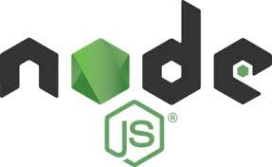

**Key Features of Node.js**

1. **Non-Blocking I/O:** Node.js operates on a non-blocking, asynchronous I/O model, meaning that it can handle multiple operations concurrently without waiting for one operation to complete before starting another. This model enhances the performance and scalability of applications by allowing them to process multiple requests simultaneously.
2. **Event-Driven Architecture:** Node.js uses an event-driven architecture where operations are handled through events and callbacks. This approach allows applications to react to various events (e.g., incoming requests, file reads) and execute code in response, improving efficiency and responsiveness.
3. **Single-Threaded Model:** Despite its ability to handle many connections concurrently, Node.js runs on a single thread. It leverages the event loop to manage multiple tasks, which helps in reducing the complexity of multi-threaded programming while still delivering high concurrency.
4. **JavaScript Everywhere:** Node.js enables full-stack JavaScript development by allowing developers to use JavaScript on both the client and server sides. This unified language stack simplifies development and promotes code reuse across the entire application.
5. **NPM (Node Package Manager):** Node.js comes with NPM, a powerful package manager that hosts a vast repository of open-source libraries and modules. Developers can easily install, manage, and share packages to enhance functionality and streamline development.
6. **Scalability:** Node.js supports scalability through its event-driven model and clustering. Developers can create scalable network applications and distribute workloads across multiple CPU cores using Node.js’s built-in clustering module.
7. **Cross-Platform:** Node.js is cross-platform, running on various operating systems, including Windows, macOS, and Linux. This flexibility makes it suitable for a wide range of development environments.
8. **Real-Time Applications:** Node.js is well-suited for building real-time applications such as chat applications, live streaming services, and online gaming platforms, thanks to its asynchronous and event-driven nature.
9. **Microservices Architecture:** Node.js is often used in microservices architectures, where applications are composed of small, independent services that communicate with each other. Its lightweight nature and efficient performance make it ideal for this architectural style.
10. **Built-in Libraries:** Node.js includes a range of built-in libraries and modules for common tasks such as HTTP, file system operations, and streams. These libraries simplify development by providing essential functionalities without requiring third-party dependencies.

**Advantages of Using Node.js**

1. **High Performance:** Node.js’s non-blocking I/O and event-driven architecture contribute to its high performance, enabling it to handle a large number of concurrent connections efficiently.
2. **Scalable Architecture:** The ability to scale applications horizontally and vertically, combined with Node.js’s clustering capabilities, supports the development of scalable and high-performance systems.
3. **Unified Language:** Using JavaScript for both client-side and server-side development streamlines development processes, reduces context switching, and allows for code reuse.
4. **Rapid Development:** The extensive ecosystem of NPM packages accelerates development by providing reusable components and libraries that address common requirements.
5. **Real-Time Capabilities:** Node.js excels in real-time applications due to its asynchronous nature, enabling features like real-time communication and live updates.
6. **Active Community:** A vibrant and active community contributes to the continuous improvement of Node.js, providing support, updates, and a wealth of resources for developers.
7. **Microservices-Friendly:** Its lightweight and modular design makes Node.js a good fit for building microservices, allowing for easier maintenance and scalability of complex systems.
8. **Cross-Platform Compatibility:** Node.js’s cross-platform capabilities enable developers to build applications that run seamlessly across different operating systems.
9. **Asynchronous Processing:** Node.js’s asynchronous processing model improves application responsiveness and reduces latency, which is beneficial for performance-sensitive applications.
10. **Streamlined Development:** The comprehensive set of built-in libraries and tools available with Node.js simplifies development and reduces the need for additional dependencies.

**4.4. Express.js**

Express.js, commonly referred to as Express, is a minimal and flexible web application framework for Node.js. It provides a robust set of features for building web and mobile applications and is widely used for creating server-side applications and APIs. Express simplifies the development of server-side logic by providing a straightforward and powerful API, making it one of the most popular frameworks for Node.js.



**Key Features of Express.js**

1. **Minimalist and Lightweight:** Express.js is designed to be minimal and lightweight, offering just the essentials needed to build web applications and APIs. This minimalism allows developers to have greater control and flexibility over their application structure.
2. **Middleware:** Express.js uses a middleware-based architecture, allowing developers to add layers of functionality to the request and response pipeline. Middleware functions can handle tasks such as authentication, logging, error handling, and parsing request bodies.
3. **Routing:** Express provides a powerful routing system for defining and handling HTTP routes. Developers can create routes for different HTTP methods (GET, POST, PUT, DELETE) and map them to specific handlers, making it easy to manage application endpoints.
4. **Template Engine Integration:** Express supports integration with various template engines, such as Pug (formerly Jade), EJS, and Handlebars. This feature allows developers to render dynamic HTML pages based on server-side data.
5. **Error Handling:** Express provides built-in error handling mechanisms to manage and respond to errors in a consistent manner. Developers can define custom error-handling middleware to handle different types of errors and send appropriate responses to clients.
6. **Static File Serving:** Express includes built-in support for serving static files (e.g., images, CSS, JavaScript) from a specified directory. This feature simplifies the process of delivering static assets to clients.
7. **Flexible Configuration:** Express allows for flexible configuration, including support for environment-specific settings and configuration files. This flexibility helps in managing different environments such as development, staging, and production.
8. **Community and Ecosystem:** Express has a large and active community, with a rich ecosystem of middleware, plugins, and extensions. This ecosystem provides a wide range of additional functionalities and integrations that can enhance the capabilities of Express applications.
9. **Asynchronous Operations:** Express leverages Node.js’s asynchronous nature, allowing for efficient handling of concurrent requests and non-blocking operations. This characteristic contributes to the performance and scalability of Express applications.
10. **RESTful API Development:** Express is well-suited for building RESTful APIs due to its routing and middleware capabilities. Developers can easily define API endpoints, handle HTTP methods, and manage request and response data.

**Advantages of Using Express.js**

1. **Ease of Use:** Express provides a simple and intuitive API that streamlines the development process. Its minimalist design makes it easy for developers to get started and build robust applications quickly.
2. **Flexibility:** The framework’s flexible nature allows developers to structure their applications in various ways and choose the middleware and tools that best suit their needs.
3. **Middleware Support:** The use of middleware functions enables developers to modularize application functionality, handle tasks efficiently, and manage the request-response cycle effectively.
4. **Powerful Routing:** Express’s powerful routing system allows for the creation of complex routing logic with ease, supporting dynamic and parameterized routes.
5. **Large Ecosystem:** The extensive ecosystem of middleware and extensions available for Express enhances its functionality and allows developers to integrate with other technologies and services seamlessly.
6. **Integration with Node.js:** Express leverages Node.js’s asynchronous capabilities, enabling the development of high-performance and scalable applications that can handle a large number of concurrent connections.
7. **Template Engine Support:** The ability to integrate with various template engines allows developers to render dynamic content and build server-side rendered applications efficiently.
8. **Robust Error Handling:** Express’s built-in error handling mechanisms help ensure that errors are managed gracefully, providing a consistent experience for both developers and users.
9. **Static File Management:** The built-in support for serving static files simplifies the process of delivering assets, reducing the need for additional configurations or dependencies.
10. **Community Support:** The active community and extensive documentation provide valuable resources, support, and best practices for working with Express.js.

**4.4.1. Visual Studio Code:**

Visual Studio Code, commonly referred to as VS Code, is a free, open-source code editor developed by Microsoft. It is available on Windows, macOS, and Linux and is widely used by developers for writing and editing code across various programming languages. VS Code is known for its lightweight nature, extensibility, and rich feature set, which makes it a popular choice among developers for various types of software development projects.



**Key Features of VS Code**

1. **Intelligent Code Editing:** VS Code offers advanced code editing features such as syntax highlighting, code completion, IntelliSense (context-aware code suggestions), and error detection. These features enhance productivity and help developers write code more efficiently.
2. **Extensibility:** VS Code supports a vast array of extensions available through the Visual Studio Code Marketplace. Extensions can add new functionalities, support additional programming languages, integrate with tools and services, and customize the editor to fit specific workflows.
3. **Integrated Terminal:** VS Code includes an integrated terminal that allows developers to run command-line commands and scripts directly within the editor. This feature eliminates the need to switch between the editor and a separate terminal application.
4. **Debugging Support:** The editor provides robust debugging capabilities, including breakpoints, step-through debugging, variable inspection, and call stack management. This built-in support helps developers identify and resolve issues more effectively.
5. **Version Control Integration:** VS Code integrates with popular version control systems like Git. It provides features for managing source code, committing changes, creating branches, and resolving merge conflicts directly from within the editor.
6. **Code Navigation:** Features such as Go to Definition, Find All References, and Symbol Search allow developers to navigate through their codebase efficiently. These tools improve code exploration and make it easier to understand and modify existing code.
7. **Customizable User Interface:** VS Code offers a highly customizable user interface, including support for themes, layout adjustments, and keybindings. Users can personalize the editor to match their preferences and workflow.
8. **Live Share:** The Live Share extension enables real-time collaborative coding sessions, allowing multiple developers to work on the same codebase simultaneously. This feature facilitates pair programming and collaborative debugging.
9. **Snippets and Emmet:** VS Code supports code snippets and Emmet, which help speed up coding by providing shortcuts for frequently used code patterns and abbreviations. Snippets can be customized to fit specific coding needs.
10. **Task Automation:** VS Code allows for the automation of common tasks through tasks.json configuration. Developers can define custom tasks for building, testing, and running applications, integrating with various tools and scripts.

**Advantages of Using VS Code**

1. **Lightweight and Fast:** VS Code is designed to be lightweight and fast, providing a responsive experience even with large codebases and complex projects.
2. **Cross-Platform:** The editor is available on Windows, macOS, and Linux, allowing developers to use the same tool across different operating systems.
3. **Extensive Ecosystem:** The vast library of extensions available through the Marketplace enhances the functionality of VS Code, enabling developers to tailor the editor to their specific needs and preferences.
4. **Integrated Tools:** The inclusion of integrated tools such as the terminal, debugger, and version control support streamlines development workflows and reduces context switching.
5. **Strong Community Support:** VS Code has an active and engaged community, providing ample resources, tutorials, and support through forums, documentation, and extension contributions.
6. **Customizable Workflows:** The editor’s flexibility allows for customization of keybindings, themes, and layouts, catering to individual developer preferences and improving productivity.
7. **Real-Time Collaboration:** Features like Live Share enable real-time collaboration, making it easier for teams to work together on code and resolve issues in real time.
8. **Built-in Git Integration:** The integrated Git support simplifies version control operations, allowing for seamless source code management and collaboration.
9. **Extensible Debugging:** The editor’s debugging capabilities are highly extensible, supporting a wide range of programming languages and debugging scenarios through extensions.
10. **Regular Updates:** VS Code receives regular updates and improvements from Microsoft, ensuring that the editor stays current with the latest features and enhancements.

**4.4.4 TAILWIND CSS:**

Tailwind CSS is a utility-first CSS framework designed to provide a highly customizable and flexible approach to building modern user interfaces. Unlike traditional CSS frameworks that offer predefined components and styles, Tailwind CSS allows developers to build custom designs by applying utility classes directly to HTML elements. This approach promotes rapid development and consistent design while maintaining flexibility and control**.**

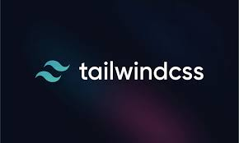

**Features of Tailwind CSS**

1. Utility-First Approach: Tailwind CSS employs a utility-first approach, where small, reusable utility classes (such as .bg-blue-500, .text-center, or. p-4) are applied to elements to style them. This method allows for precise control over styling and encourages a composable approach to building UIs.
2. Highly Customizable: Tailwind provides extensive customization options through its configuration file (tailwind.config.js). Developers can define custom colors, spacing, fonts, and other design tokens, ensuring that the framework aligns with the specific needs and branding of a project.
3. Responsive Design: Tailwind includes built-in responsive design utilities that enable developers to create responsive layouts easily. By using responsive variants (e.g., sm: md: lg:), developers can apply different styles at various screen sizes.
4. Flexibility and Composability: Tailwind’s utility classes are designed to be composable, meaning that multiple classes can be combined to achieve complex designs. This composability allows for a high degree of flexibility in styling without the need for writing custom CSS.
5. Predefined Breakpoints: The framework includes a set of predefined breakpoints for responsive design, which can be customized if needed. These breakpoints help create adaptive layouts that work across different devices and screen sizes.
6. Dark Mode Support: Tailwind CSS provides support for dark mode, allowing developers to create designs that automatically switch between light and dark themes based on user preferences or system settings.
7. Purge CSS Integration: Tailwind includes built-in support for PurgeCSS, a tool that removes unused CSS classes from the final build. This integration helps reduce the size of CSS files and improves performance by keeping the stylesheet lean and efficient.
8. Design System Integration: Tailwind can be used as part of a larger design system, providing a consistent set of design patterns and styles that can be shared across different projects and components.
9. Plugins and Extensions: Tailwind CSS supports a variety of plugins and extensions that enhance its functionality. Plugins can add new utilities, components, or features, allowing developers to extend the capabilities of the framework.
10. Documentation and Community: Tailwind CSS boasts comprehensive documentation that covers all aspects of the framework, including utility classes, configuration, and customization. The framework also has a vibrant community that contributes to its development and provides support through forums, GitHub issues, and community resources.

**Advantages of Using Tailwind CSS**

1. Rapid Development: The utility-first approach allows for rapid development and prototyping by applying pre-defined classes directly to elements. This method speeds up the styling process and reduces the need for writing custom CSS.
2. Consistent Design: Tailwind’s utility classes promote consistency in design by encouraging the reuse of the same classes across different parts of the application. This consistency helps maintain a cohesive look and feel.
3. Highly Customizable: The framework’s configuration file allows for extensive customization, making it easy to align Tailwind with specific project requirements and design systems.
4. Responsive Design Made Easy: Tailwind’s responsive utilities make it straightforward to create designs that adapt to different screen sizes without writing media queries manually.
5. Reduced CSS Bloat: By integrating with PurgeCSS, Tailwind ensures that only the used CSS classes are included in the final build, minimizing the size of the stylesheet and improving performance.
6. No Need for Custom CSS: Tailwind’s comprehensive set of utility classes reduces the need for writing custom CSS, making it easier to manage styles and maintain the codebase.
7. Design Flexibility: The framework’s composable nature allows for a high degree of design flexibility, enabling developers to create unique and complex layouts without being constrained by predefined components.
8. Enhanced Collaboration: The use of utility classes promotes consistency and simplifies collaboration between designers and developers, as the design system is clearly defined through the utility classes.
9. Strong Ecosystem: Tailwind CSS has a growing ecosystem of plugins and extensions that add additional functionality, components, and utilities, further enhancing its capabilities.
10. Active Community: The framework’s active community provides valuable support, contributes to its development, and creates a wealth of resources, including tutorials, components, and design patterns.

**CHAPTER 5**

**SYSTEM DESIGN**

**5.1 DATA FLOW DIAGRAM:**

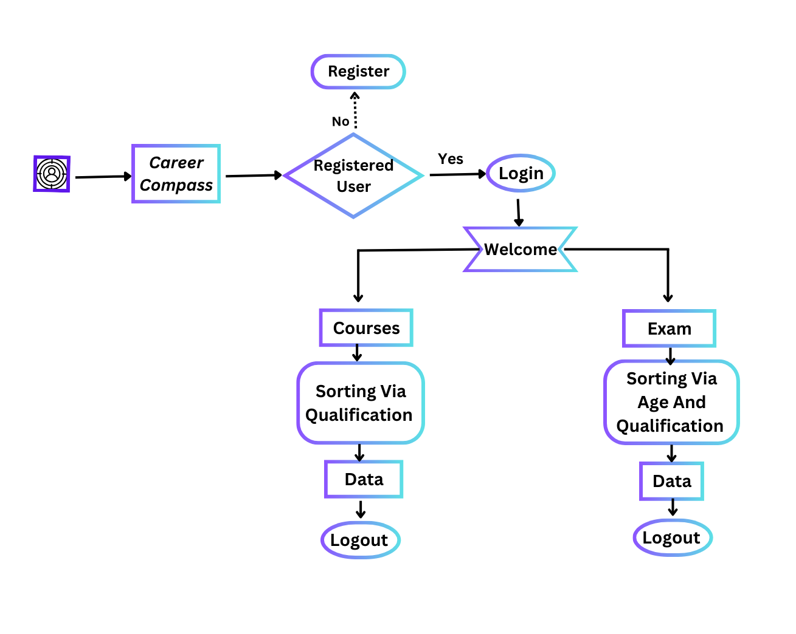

The Data Flow diagram of Career Compass is Presented above to give a better understanding of the application and its whole process to the users.

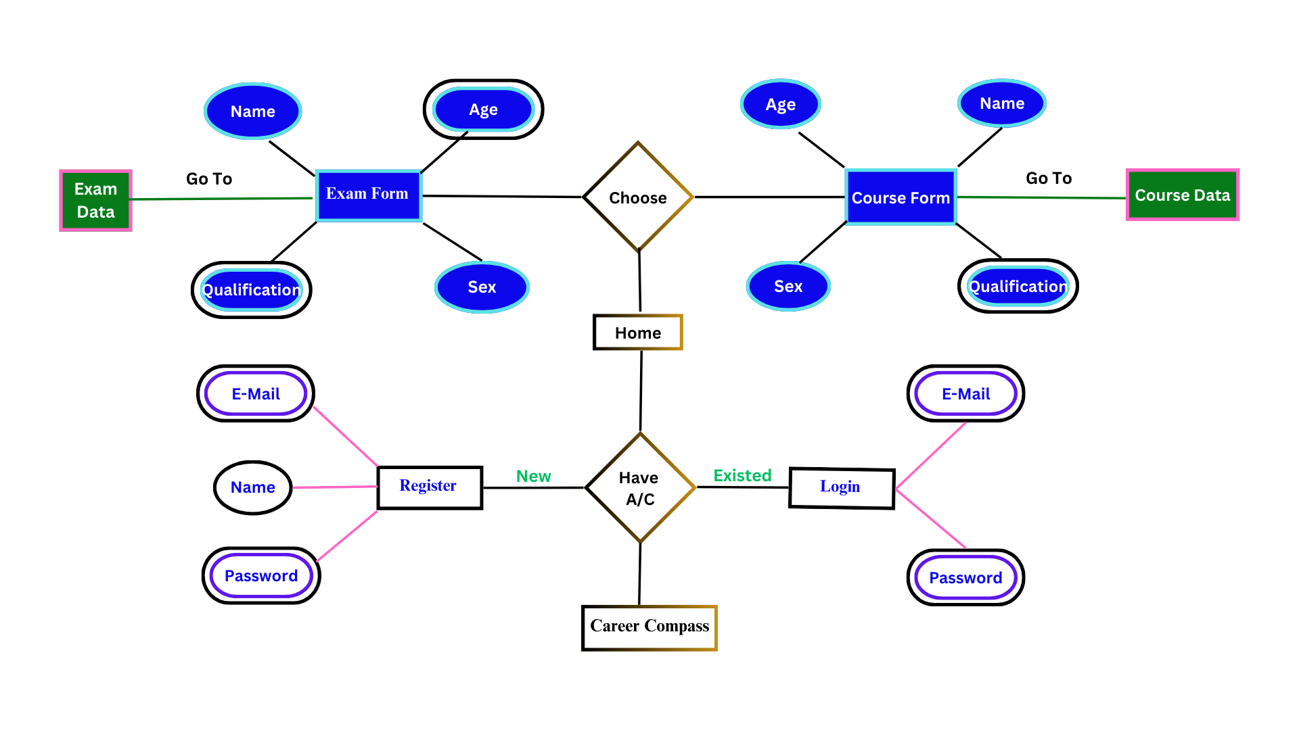**5.2. ENTITY-RELATIONSHIP DIAGRAM (ER DIAGRAM):**

**ER Diagram of career compass**

**5.3 USE CASE DIAGRAM:**

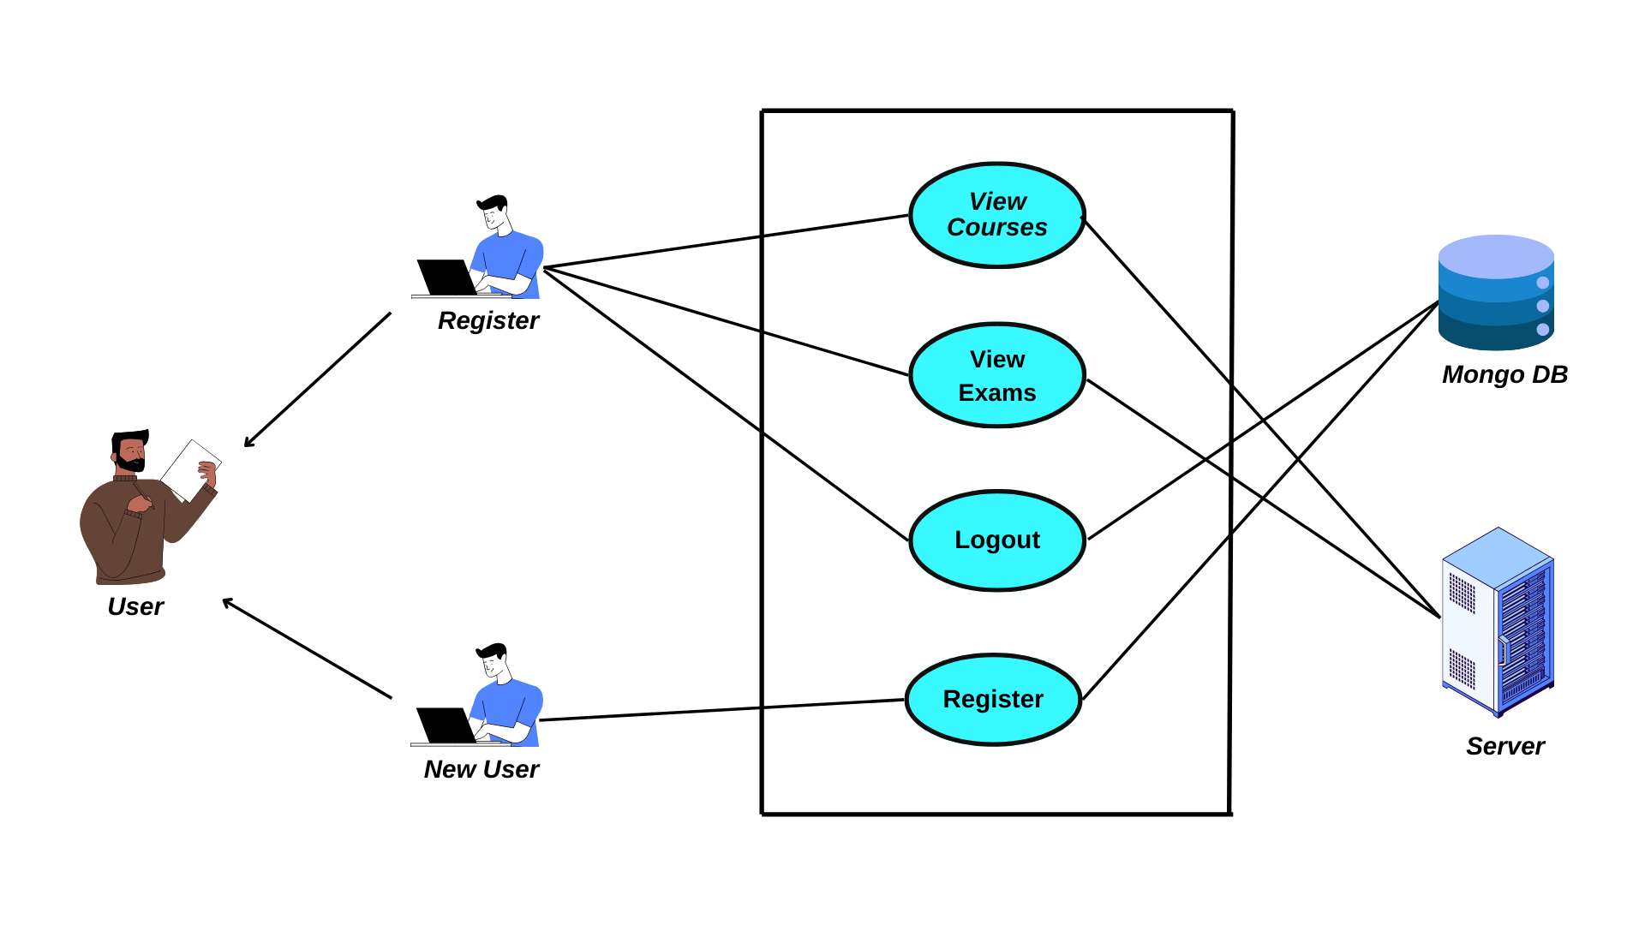

**Use case diagram for Career Compass**

**CHAPTER 6**

**SYSTEM TESTING**

**6.1. TESTING DEFINITION**

Software testing in the software development life cycle (SDLC) that involves the evaluation of a software application or system to ensure that it meets specified requirements and functions correctly. The primary goal of testing is to identify defects or bugs that may affect the software's performance, reliability, and functionality. Testing helps in delivering a high-quality and error-free software product.

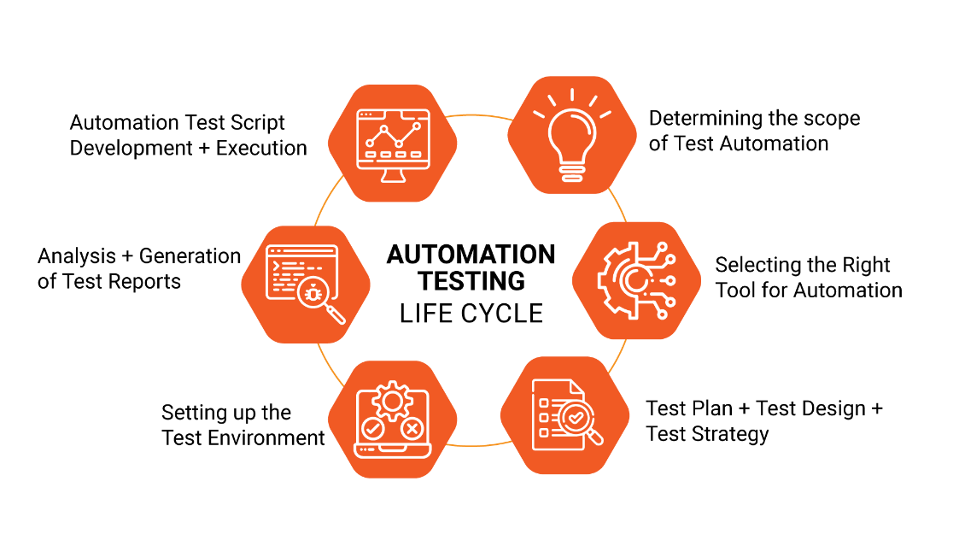

**6.1.1. Types of Software Testing**

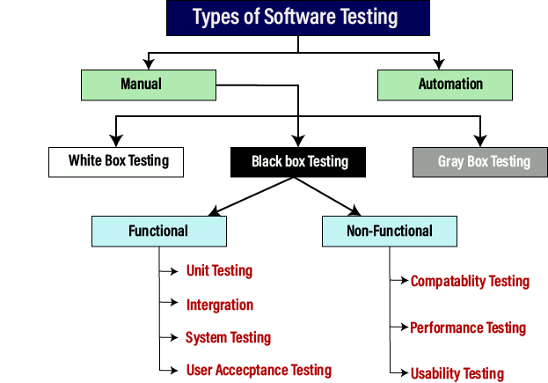

## 6.1.2. Testing Methodologies

* **Manual Testing**

Manual testing is a traditional testing approach where human testers manually execute test cases without the aid of automation tools. Testers simulate end-user scenarios to identify defects, ensure correct functionality, and validate system usability. Manual testing is cost-effective for smaller projects and is particularly effective for exploratory testing where the tester explores the application to identify defects that may have been overlooked in the development process.

* **Unit Testing**

Unit testing focuses on testing individual units or components of the software in isolation. It ensures that each unit functions as intended and helps identify defects early in the development process. Unit testing is advantageous for improving code quality, facilitating easier debugging, and providing rapid feedback to developers during the coding phase.

* **Integration Testing**

Integration testing verifies the interaction between different modules or components to ensure they work together seamlessly. It aims to identify issues related to module communication, data flow, and overall integration. Integration testing is valuable for early detection of interface problems and improving the reliability of the entire system.

* **System Testing**

System testing evaluates the overall functionality of the entire software system to ensure it meets specified requirements. It involves testing the system as a whole, considering both functional and non-functional aspects. System testing is critical for identifying system-level issues, validating system behavior against requirements, and ensuring the software is ready for release.

* **Acceptance Testing**

Acceptance testing validates whether the software meets user requirements and is ready for deployment. This type of testing ensures customer satisfaction, confirms that business objectives are met, and provides the final validation before the software is released to production. Acceptance testing can take the form of user acceptance testing (UAT) where end-users validate the system against their needs.

* **Performance Testing**

Performance testing evaluates the responsiveness, scalability, and stability of the software under varying conditions. It includes different types of testing such as load testing, stress testing, and scalability testing. Performance testing is essential for identifying performance bottlenecks, ensuring system reliability under various loads, and validating system responsiveness.

## 6.1.3. Test Cases and Expected Results

**Citizen Dashboard**

1. **Registration with Aadhar**
   * Test Case ID: DRTWA_CIT_001
   * Input: Valid Aadhar details
   * Expected Result: Successful registration
   * Actual Result: Successful registration
   * Status: Pass
2. **OTP Verification**
   * Test Case ID: DRTWA_CIT_002
   * Input: Valid OTP
   * Expected Result: Successful verification
   * Actual Result: Successful verification
   * Status: Pass
3. **Login**
   * Test Case ID: DRTWA_CIT_003
   * Input: Valid login credentials
   * Expected Result: Secure login
   * Actual Result: Secure login
   * Status: Pass
4. **Apply for Disaster Relief Fund**
   * Test Case ID: DRTWA_CIT_004
   * Input: Proper application details
   * Expected Result: Successful application submission
   * Actual Result: Successful application submission
   * Status: Pass
5. **Track Application Status**
   * Test Case ID: DRTWA_CIT_005
   * Input: Application ID
   * Expected Result: Real-time tracking of application status
   * Actual Result: Real-time tracking of application status
   * Status: Pass
6. **Receive Notification**
   * Test Case ID: DRTWA_CIT_006
   * Input: Application status change
   * Expected Result: Timely notification
   * Actual Result: Timely notification
   * Status: Pass

**Review Committee Dashboard**

1. **Login**
   * Test Case ID: DRTWA_RC_001
   * Input: Valid credentials
   * Expected Result: Successful login
   * Actual Result: Successful login
   * Status: Pass
2. **Receive Applications**
   * Test Case ID: DRTWA_RC_002
   * Input: Applications submitted by citizens
   * Expected Result: Proper redirection of applications
   * Actual Result: Proper redirection of applications
   * Status: Pass
3. **Review and Assess**
   * Test Case ID: DRTWA_RC_003
   * Input: Application details, damage assessment
   * Expected Result: Proper review and assessment
   * Actual Result: Proper review and assessment
   * Status: Pass
4. **Approve/Reject Application**

* Test Case ID: DRTWA_RC_004
* Input: Assessment scores
* Expected Result: Correct approval/rejection
* Actual Result: Correct approval/rejection
* Status: Pass

1. **Priority List**

* Test Case ID: DRTWA_RC_005
* Input: Approved applications
* Expected Result: Generation of a priority list
* Actual Result: Generation of a priority list
* Status: Pass

**State Executive Committee Dashboard**

1. **Login**
   * Test Case ID: DRTWA_SEC_001
   * Input: Valid credentials
   * Expected Result: Successful login
   * Actual Result: Successful login
   * Status: Pass
2. **View Approved Applications**
   * Test Case ID: DRTWA_SEC_002
   * Input: Approved applications
   * Expected Result: Access to approved applications
   * Actual Result: Access to approved applications
   * Status: Pass
3. **Process Applications**
   * Test Case ID: DRTWA_SEC_003
   * Input: Review and assessment details
   * Expected Result: Correct processing of applications
   * Actual Result: Correct processing of applications
   * Status: Pass
4. **Forward to Treasury/Revenue Department**
   * Test Case ID: DRTWA_SEC_004
   * Input: Approved applications and fund details
   * Expected Result: Proper forwarding of applications
   * Actual Result: Proper forwarding of applications
   * Status: Pass

**Treasury or Revenue Department Dashboard**

1. **Login**
   * Test Case ID: DRTWA_TRD_001
   * Input: Valid credentials
   * Expected Result: Successful login
   * Actual Result: Successful login
   * Status: Pass
2. **View Approved Applications**
   * Test Case ID: DRTWA_TRD_002
   * Input: Approved applications
   * Expected Result: Access to approved applications
   * Actual Result: Access to approved applications
   * Status: Pass
3. **Process Applications**
   * Test Case ID: DRTWA_TRD_003
   * Input: Approved applications and details
   * Expected Result: Proper processing of applications
   * Actual Result: Proper processing of applications
   * Status: Pass
4. **Release Fund to Financial Agencies**
   * Test Case ID: DRTWA_TRD_004
   * Input: Fund details and approved applications
   * Expected Result: Correct fund release
   * Actual Result: Correct fund release
   * Status: Pass

**Authorized Bank Dashboard**

1. **Login with Received Credentials**
   * Test Case ID: DRTWA_ABD_001
   * Input: Received credentials
   * Expected Result: Successful login
   * Actual Result: Successful login
   * Status: Pass
2. **Receive Relief Fund Distribution List**
   * Test Case ID: DRTWA_ABD_002
   * Input: List of approved applications and fund details
   * Expected Result: Access to the distribution list
   * Actual Result: Access to the distribution list
   * Status: Pass
3. **View and Process Fund Distribution**
   * Test Case ID: DRTWA_ABD_003
   * Input: Details of fund distribution
   * Expected Result: Correct fund distribution process
   * Actual Result: Correct fund distribution process
   * Status: Pass
4. **Transfer List Submission**
   * Test Case ID: DRTWA_ABD_004
   * Input: List of fund transfers
   * Expected Result: Proper submission of the transfer list
   * Actual Result: Proper submission of the transfer list
   * Status: Pass

**Disaster Management Authority or Disaster Regulator Dashboard**

1. **Login**
   * Test Case ID: DRTWA_DMA_001
   * Input: Default credentials
   * Expected Result: Successful login
   * Actual Result: Successful login
   * Status: Pass
2. **Add and Manage Committees and Departments**
   * Test Case ID: DRTWA_DMA_002
   * Input: Committee and department details
   * Expected Result: Successful addition and management
   * Actual Result: Successful addition and management
   * Status: Pass
3. **View Citizen Registration and Applications**
   * Test Case ID: DRTWA_DMA_003
   * Input: Citizen registration and application details
   * Expected Result: Proper monitoring of registrations and applications
   * Actual Result: Proper monitoring of registrations and applications
   * Status: Pass
4. **Verification and Notification**
   * Test Case ID: DRTWA_DMA_004
   * Input: Verification details and notifications
   * Expected Result: Timely verification and notification
   * Actual Result: Timely verification and notification
   * Status: Pass
5. **Receive Lists and Fund Details**
   * Test Case ID: DRTWA_DMA_005
   * Input: Lists of approved and rejected applications with fund details
   * Expected Result: Access to lists and fund details
   * Actual Result: Access to lists and fund details
   * Status: Pass

**6.1.4. TEST REPORT**

**Introduction**

This test report covers the comprehensive testing of the Dashboard Modules in the system. The Dashboard Modules include Citizen Dashboard, Review Committee Dashboard, State Executive Committee Dashboard, Treasury or Revenue Department Dashboard, Authorized Bank Dashboard, and Disaster Management Authority or Disaster Regulator Dashboard. The testing aimed to ensure the functionality, security, and user-friendliness of each dashboard.

**Test Objective**

The primary objective of the testing was to validate the functionality of the Disaster Relief Fund Tracker Web App, ensuring that all modules, dashboards, and features perform as intended. The testing aimed to identify and address any potential issues, ensuring a robust and user-friendly system for disaster relief fund distribution.

**Test Scope**

The testing scope covered all modules and functionalities of the Disaster Relief Fund Tracker Web App, including Citizen Dashboard, Review Committee Dashboard, State Executive Committee Dashboard, Treasury or Revenue Department Dashboard, Authorized Bank Dashboard, and Disaster Management Authority or Disaster Regulator Dashboard. The testing encompassed user interactions, data processing, fund allocation, and communication modules.

**Test Environment**

* **Web Browser:** Chrome, Firefox, Safari
* **Devices:** Desktop, Laptop, Mobile
* **Operating Systems:** Windows, macOS, iOS, Android
* **Internet Connection:** High-speed internet for real-time communication testing

**Test Conclusion**

The testing process for the Disaster Relief Fund Tracker Web App has been thorough and comprehensive. Based on the results obtained, it can be concluded that the application is ready for deployment. All critical functionalities have been successfully validated, and the system has demonstrated reliability, security, and efficiency.

**CHAPTER 7**

**SYSTEM IMPLEMENTATION**Top of Form

**7.1. SYSTEM DESCRIPTION**

The proposed disaster relief fund distribution system represents a modern and digital platform designed to revolutionize the efficiency and transparency of relief processes. Citizens can seamlessly submit applications online through a user-friendly interface, eliminating the complexities associated with traditional manual methods. Leveraging digital tools for verification, assessment, and scoring accelerates the decision-making process, ensuring swift approval based on predefined criteria. Real-time communication channels, including SMS, E-Mail, and In-App notifications, enable instant updates for all stakeholders, fostering a more responsive relief ecosystem. The system prioritizes transparency in fund allocation, utilizing digital platforms to prioritize applications based on severity and urgency, thereby ensuring equitable distribution. A centralized and secure digital database streamlines data management, offering efficient storage and retrieval of application information. Digital fund disbursement methods, such as secure online transactions, expedite the financial aspect of relief efforts. A robust reporting module empowers stakeholders with customizable reports, facilitating comprehensive data analysis and informed decision-making. For citizens, an intuitive web dashboard simplifies the application process, allowing them to track application status and receive timely notifications. The inclusion of a digital feedback mechanism empowers citizens to provide valuable input, contributing to continuous improvement in relief efforts. The system's secure and scalable infrastructure ensures data integrity and adaptability to evolving needs, while a centralized collaboration platform enhances coordination among relief committees, authorities, and agencies. In essence, the proposed system seeks to replace traditional relief fund distribution methods with a technologically advanced approach that prioritizes efficiency, transparency, and responsiveness to the needs of communities affected by disasters.

**7.2. SYSTEM FLOW**

1. **User Registration and Verification**
   * Citizens register on the platform using Aadhar for secure and verified profiles.
   * Verification is conducted through OTP to enhance security.
2. **User Login**
   * Authenticated users securely log into their accounts, creating a personalized environment.
3. **Application Form Submission**
   * Citizens fill out a comprehensive application form with personal information and details about the extent of damage.
4. **Document Upload**
   * Users can upload supporting documents (proof of residence, damage photographs) to substantiate their application.
5. **Real-time Tracking**
   * Citizens can track the real-time status of their applications, keeping them informed about the decision-making process.
6. **Automated Notifications**
   * Automated notifications are sent to applicants, keeping them updated on changes in their application status.
7. **Review Committee Actions**
   * Applications are assigned to the Review Committee for thorough examination.
   * Government officials verify information, conduct on-site inspections, and assess the extent of damage.
   * The Review Committee applies a scoring system based on predefined criteria.
8. **Priority List Generation**
   * Approved applications contribute to a priority list based on severity and urgency, ensuring systematic fund allocation.
9. **Approval/Rejection Decision**
   * The Review Committee makes a decision to either approve or reject the application based on the verification process and assessment score.
10. **Forward to State Executive Committee**

* If approved, the decision, along with the priority list, is forwarded to the State Executive Committee for further review and processing.

1. **State Executive Committee Actions**

* Committee members log in and access approved applications, their assessment scores, and priority lists.
* Applications are reviewed, and decisions are made to either approve or disapprove relief fund applications.

1. **Forward to Treasury/Revenue Department**

* If approved, applications with fund details are forwarded to the Treasury or Revenue Department.

1. **Treasury/Revenue Department Actions**

* Authorized personnel log in and verify details, confirming with the State Executive Committee.
* Approved funds are released to financial agencies or authorized banks based on the applications.

1. **Financial Agencies/Banks Actions**

* Authorized banks log in and receive fund distribution lists, fund details, and citizen information.
* They verify details and initiate fund distribution through various methods (direct transfer, account transfer, cheque).

1. **Disaster Management Authority Actions**

* Authorities log in, add/manage committees and departments, and oversee the overall process.
* They verify delays in application processing and notify relevant departments for resolution.

1. **Notification Module**

* Automated notifications are sent to citizens, Review Committees, State Executive Committees, Treasury, and Financial Agencies.
* Effective communication is ensured through SMS, E-Mail, and In-App notifications based on stakeholders' preferences.

1. **Reports Module**

* Stakeholders generate reports for application status, fund allocation and utilization, disbursement status, and financial compliance.
* Customizable report parameters allow stakeholders to focus on specific aspects.
* Generated reports can be exported in various formats (PDF, Excel) for easy sharing and collaboration.

**7.3. MODULE DESCRIPTION**

**1. Disaster Relief Tracker Web App**

The Disaster Relief Tracker Web App is designed and developed using Python, Flask, MySQL, and Bootstrap, ensuring a robust and efficient relief fund distribution system. The User Authentication and Access Control module guarantees secure logins with Flask's user management. The Dashboard Interface is crafted with Bootstrap for a responsive and visually appealing real-time display of relief efforts. The Application Submission and Verification modules utilize Python and Flask to seamlessly handle citizen submissions, with MySQL managing the database for storing and retrieving application details. Citizens easily submit applications, while government officials use tools for verification and assessment, including on-site inspections. The State Executive Committee reviews and approves projects based on predetermined criteria, with an automated priority list ensuring systematic fund allocation. The app integrates with Treasury and Disaster Management Authority for fund allocation, earmarking, and disbursement. Real-time analytics offer insights, and a communication system keeps stakeholders informed. Feedback mechanisms and documentation ensure transparency, while GIS integration aids in mapping affected areas. An audit trail maintains accountability, and training resources enhance user proficiency in this accessible and comprehensive web app.

**2. User Dashboard**

**2.1. Citizen Dashboard:**

* **Registration with Aadhar:** Citizens register using Aadhar, ensuring secure and verified user profiles.
* **OTP Verification:** Verified with OTP for enhanced security during the registration process.
* **Login:** Authenticated users can log in securely to access the dashboard.
* **Apply for Disaster Relief Fund:** Citizens can submit relief fund applications with necessary details.
* **Track Application Status:** Real-time tracking of application status, allowing citizens to stay informed.
* **Receive Notification:** Automated notifications keep citizens updated on the status of their applications.

**2.2. Review Committee Dashboard:**

* **Login:** Members of the Review Committee log in using provided credentials.
* **Receive Applications:** Applications submitted by citizens are directed to the Review Committee.
* **Review and Assess:** Committee members review applications, assess damage, and assign scores.
* **Approve/Reject Application:** Applications are either approved or rejected based on the assessment score.
* **Priority List:** Approved applications contribute to a priority list for immediate relief.

**2.3. State Executive Committee Dashboard:**

* **Login:** State Executive Committee members log in to the dashboard.
* **View Approved Applications:** Access approved applications, their assessment scores, and priority lists.
* **Process Applications:** Review and either approve or disapprove relief fund applications.
* **Forward to Treasury/Revenue Department:** If approved, forward applications with fund details to Treasury or Revenue Department.

**2.4. Treasury or Revenue Department Dashboard:**

* **Login:** Authorized personnel log in using provided credentials.
* **View Approved Applications:** Access approved applications and verify provided details.
* **Process Applications:** Confirm details with the State Executive Committee and release funds.
* **Release Fund to Financial Agencies:** Distribute funds to financial agencies or authorized banks based on the approved applications.

**2.5. Authorized Bank Dashboard:**

* **Login with Received Credentials:** Authorized banks login with credentials received via mail and registered post.
* **Receive Relief Fund Distribution List:** Access the list of approved applications, fund details, and citizen information.
* **View and Process Fund Distribution:** Verify details and initiate fund distribution through various methods.
* **Transfer List Submission:** Submit a list of fund transfers to the Revenue Department for verification.

**2.6. Disaster Management Authority or Disaster Regulator Dashboard:**

* **Login:** Authorities log in using default credentials.
* **Add and Manage Committees and Departments:** Add, manage, and provide login credentials to Review Committees, State Executive Committees, Treasury, and Financial Agencies.
* **View Citizen Registration and Applications:** Monitor citizen registration, track relief fund applications, and manage the overall process.
* **Verification and Notification:** Verify delays in application processing and notify relevant departments for resolution.
* **Receive Lists and Fund Details:** Access approved and rejected lists with fund details, and view disbursed fund information.

**3. Apply Relief Fund**

The "Apply Relief Fund" module streamlines the process for citizens seeking financial assistance during disasters. Citizens begin by registering on the platform, providing essential details. Verification, conducted through Aadhar and OTP mechanisms, ensures a secure and verified user base. Authenticated users can then securely log into their accounts, creating a personalized and secure environment. The heart of the module is the application form, where citizens furnish personal information and details about the extent of damage, specifying the type of assistance required. To substantiate their claims, users have the option to upload supporting documents, such as proof of residence or photographs of the damage. Ensuring transparency, the system allows citizens to track the real-time status of their applications, keeping them informed about the progress and decision-making process. Automated notifications further enhance communication by updating applicants on any changes in their application status, fostering transparency and ensuring timely information dissemination. This user-centric approach facilitates a seamless and accessible process for citizens in need of disaster relief assistance.

**4. Verification and Assessment**

The "Verification and Assessment" module plays a main role in evaluating applications submitted by citizens seeking financial assistance during disasters. Initially, applications are assigned to the dedicated Review Committee for thorough examination. Government officials within this committee then verify the information provided in the applications to ensure accuracy and authenticity. This may involve on-site inspections or interviews to assess the extent of the damage and validate the submitted information. The module operates on clear and predefined criteria, encompassing factors such as the severity of damage and the urgency of assistance. Each application undergoes an objective evaluation through a scoring system, aiding in the determination of eligibility and priority. If approved, the application is integrated into a priority list based on severity and urgency, streamlining the systematic allocation of funds to those in immediate need. The Review Committee is tasked with making the decision to approve or reject the application based on the verification process and assessment score. In the event of approval, the decision, coupled with the priority list, is forwarded to the State Executive Committee for further review and processing. This ensures that the decision, along with the priority list, is escalated to higher authority for confirmation, fostering a robust and collaborative decision-making process. To maintain transparency and facilitate efficient communication, applicants receive timely notifications of the Review Committee's decision through the system. The module also encompasses features for comprehensive documentation, recording the verification process, assessment results, and decision outcomes. Real-time updates are continuously provided to relevant stakeholders, enhancing transparency and facilitating effective communication throughout the verification and assessment process. This user-centric approach ensures accountability and transparency in the allocation of relief funds.

**5. Disaster Relief Fund Approval**

The "Disaster Relief Fund Approval" is overseeing the evaluation and approval process for applications submitted by citizens in need of financial assistance during disasters. The State Executive Committee, responsible for this crucial phase, follows a systematic approach facilitated by the following key functionalities: Upon logging into the system using secure credentials, State Executive Committee members gain access to a list of approved applications and the associated priority list as determined by the Review Committee. Each application's details, including the assessment score assigned by the Review Committee, are scrutinized. The committee engages in a thorough decision-making process, carefully reviewing each application to determine whether to approve or disapprove the relief fund based on the provided details and assessment scores. Approved applications trigger the next step, involving the forwarding of decisions and fund details to the Treasury or Revenue Department for further processing and allocation. Applicants promptly receive notifications of the State Executive Committee's decisions through the system, fostering clear communication throughout the decision-making process. Real-time updates are provided to all relevant stakeholders, including the Review Committee, applicants, and other concerned parties, maintaining transparency and facilitating efficient communication. The module incorporates robust features for documentation and record-keeping, ensuring a thorough record of the State Executive Committee's decisions, approved applications, and assessment outcomes. Interaction with the Treasury or Revenue Department is seamlessly integrated to guarantee a coordinated and efficient process for the disbursement of funds. State Executive Committee members have the capability to monitor the overall progress of the approval and disbursement process in real-time through the module. This feature ensures that the relief fund distribution remains timely, effective, and aligned with the priorities established by the committee.

**6. Disaster Relief Fund Allocation**

The "Disaster Relief Fund Allocation" module is designed to oversee the distribution and allocation of approved funds to citizens in need during disasters. Authorized personnel from the Treasury or Revenue Department gain access to this module by logging in with secure credentials, ensuring controlled access. Upon entry, the department views a list of approved applications along with detailed fund allocation information provided by the State Executive Committee. The application details are carefully verified for accuracy, aligning with the decisions made by the State Executive Committee. The department reviews these decisions, ensuring proper validation before proceeding with the fund disbursement process. Subsequently, the Treasury or Revenue Department allocates the approved funds to designated financial agencies or authorized banks responsible for distributing funds to citizens. Throughout this process, real-time updates are provided to relevant stakeholders, including the State Executive Committee and financial agencies, fostering transparency and facilitating efficient communication. Applicants are promptly notified of the fund allocation through the system, offering clear communication regarding the allocated amount and the mode of distribution. The module incorporates robust features for documentation and record-keeping, ensuring a comprehensive record of the fund allocation process and maintaining accountability and transparency. The Treasury or Revenue Department interacts seamlessly with financial agencies or authorized banks to ensure a coordinated and smooth process for the distribution of funds to citizens. The module also enables the department to monitor the overall progress of fund allocation and distribution, ensuring adherence to established procedures and timelines.

**7. Disaster Relief Fund Disbursement**

The "Disaster Relief Funds Disbursement" module is the final stage of the relief fund distribution process – the actual transfer and distribution of approved funds to citizens in need. Authorized personnel from designated financial agencies or authorized banks log into the system using secure credentials, ensuring controlled access to the module. Once logged in, these entities receive a fund distribution list and details, outlining the approved allocations from the Treasury or Revenue Department. Verification is conducted to ensure accuracy and alignment with the approved fund allocations. The module enables financial agencies or banks to view detailed citizen information, including the allocated funds and the designated mode of distribution. Following verification, financial agencies or banks initiate the fund distribution process, utilizing various methods such as direct transfers, account transfers, or issuing checks to disburse funds to eligible citizens. After the funds are distributed, financial entities submit a transfer list to the Treasury or Revenue Department, providing a record of the distributed funds and confirming the completion of the distribution process. Communication between financial agencies or banks and the Disaster Management Authority or Regulator is facilitated through the module, allowing for updates on the fund distribution process and addressing any concerns or queries. Real-time updates are provided to relevant stakeholders, including the Treasury or Revenue Department and the Disaster Management Authority or Regulator, ensuring transparency and facilitating efficient communication. The module also incorporates features for documenting the fund distribution process, maintaining a comprehensive record of distributed amounts, and ensuring accountability and transparency. Financial agencies or banks can monitor the overall progress of the fund distribution process, ensuring compliance with established procedures and timelines.

**8. Notification**

The "Notification" module within the Disaster Relief Tracker Web App is a dynamic system ensuring efficient communication with stakeholders through SMS, E-Mail, and In-App notifications. Applicants receive timely updates on their relief fund applications, including approval status and disbursement details. Review Committee members are instantly alerted to new submissions, while State Executive Committee members receive notifications on approved applications and priority lists. Treasury/Revenue Department personnel are informed about approved applications and fund allocations, and financial agencies/banks receive distribution alerts. The Disaster Management Authority/Regulator is kept in the loop about overall progress. Real-time updates are consistent across channels, and stakeholders can customize their notification preferences. The module maintains comprehensive logs for accountability and analysis. This multi-channel approach ensures effective and transparent communication throughout the relief fund distribution process.

**9. Reports**

The "Reports" module serves as a robust tool for stakeholders to gain comprehensive insights into the relief fund distribution process. This module is instrumental in facilitating data analysis, informed decision-making, and ensuring transparency by generating detailed reports.

Stakeholders can leverage Application Status Reports to access key information on relief fund applications, including the number of applications received, approved, rejected, and pending. This feature provides a quick overview of the overall application process, aiding in efficient monitoring. Fund Allocation and Utilization Reports offer a breakdown of allocated funds, distribution across different regions, and insights into how funds are utilized. This functionality enhances financial transparency and supports stakeholders in making well-informed decisions regarding resource allocation. The module's Disbursement Status Reports provide detailed insights into the progress of fund distribution to citizens. It includes information on the number of disbursed applications, distribution methods employed, and any potential delays in the disbursement process, ensuring a clear overview of fund disbursement. Financial Compliance Reports generated by the module play a critical role in ensuring adherence to established guidelines for fund allocation and distribution. This not only aids in maintaining financial transparency but also supports auditing processes to guarantee compliance. One of the standout features is Customizable Report Generation, empowering users to tailor report parameters according to specific requirements. This flexibility allows stakeholders to focus on particular aspects of the relief fund distribution process, ensuring that the generated reports are highly relevant and usable. Export and Share ability functionalities enable stakeholders to export generated reports in various formats such as PDF and Excel. This ensures easy sharing and collaboration among stakeholders, promoting transparency and facilitating seamless communication.

**CHAPTER 8**

**APPENDIX**

**8.1. SCREEN SHOT**

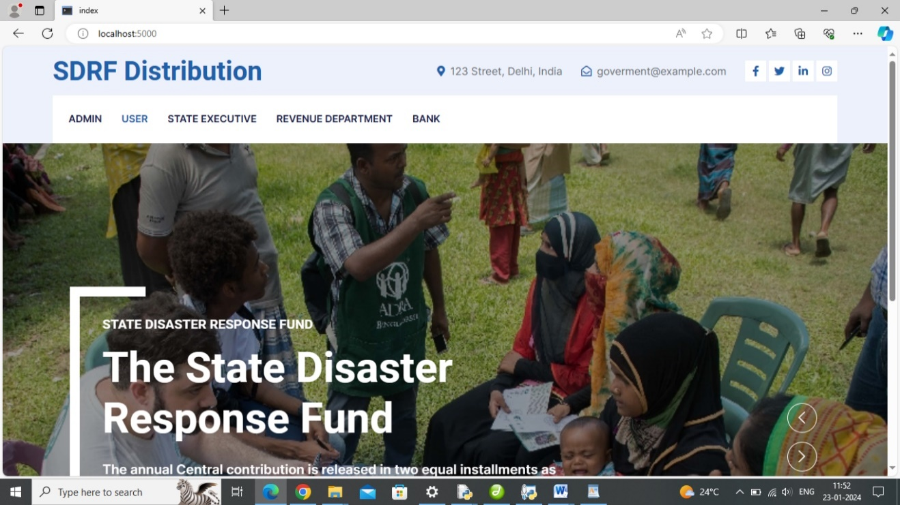

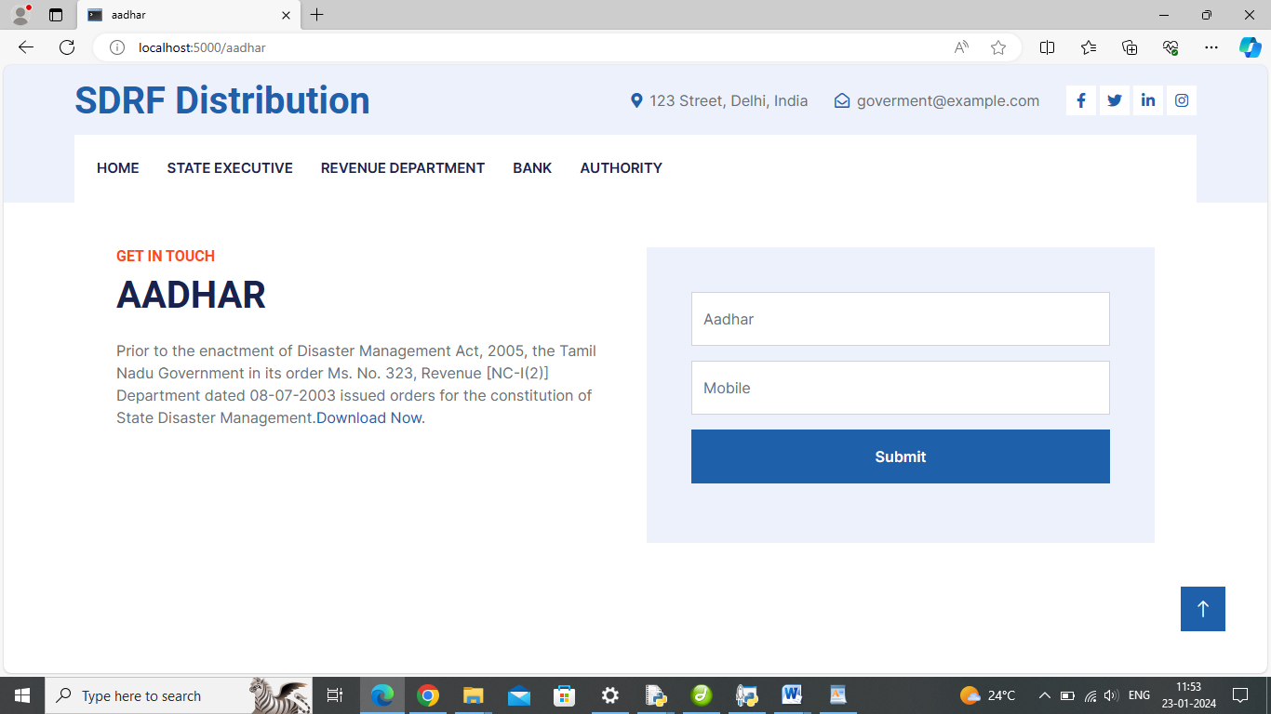

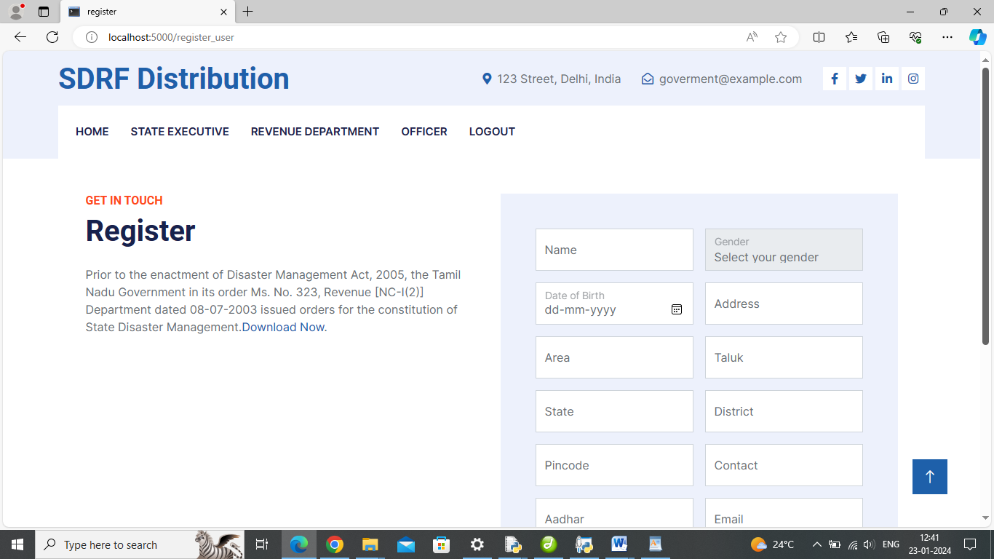

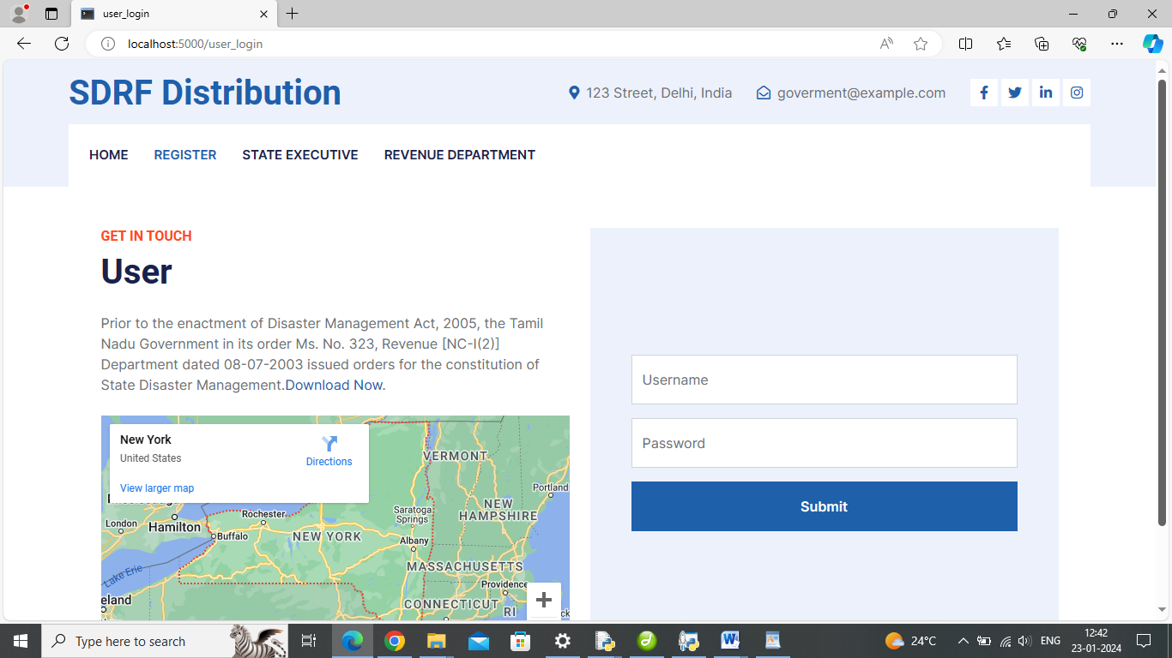



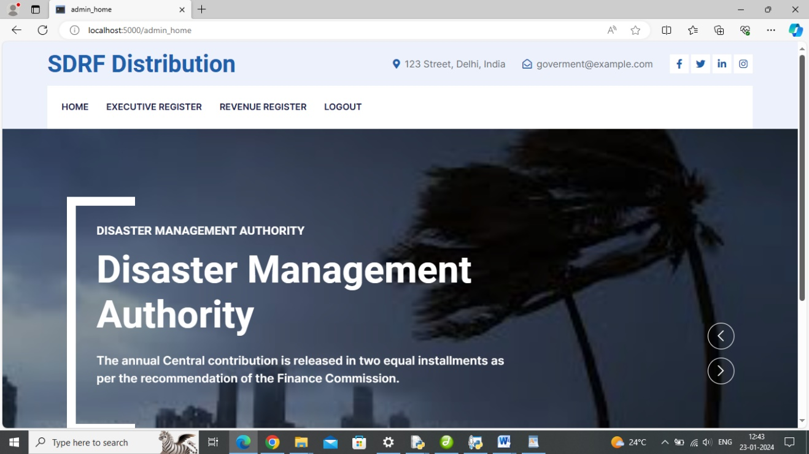

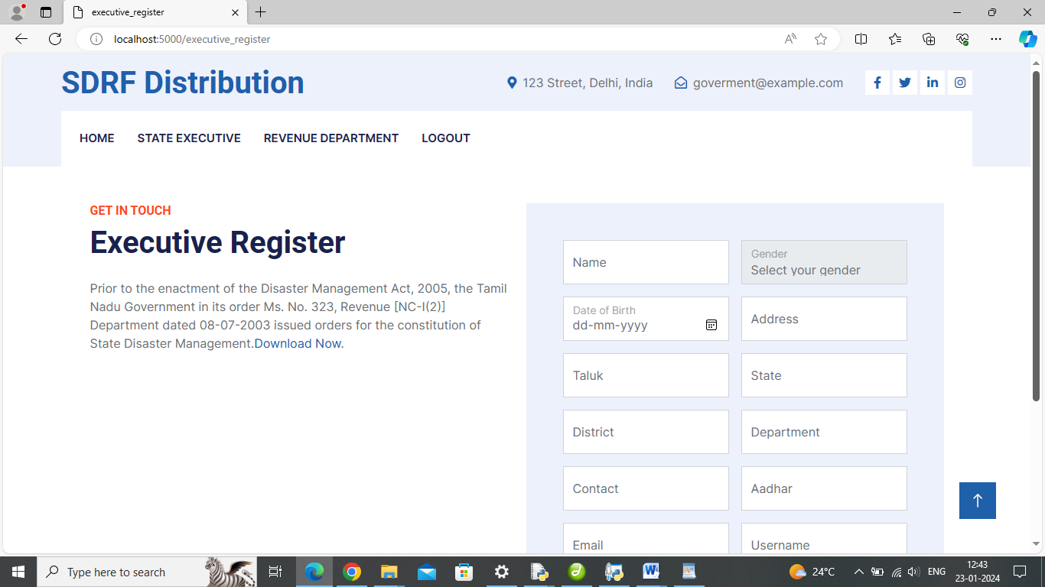

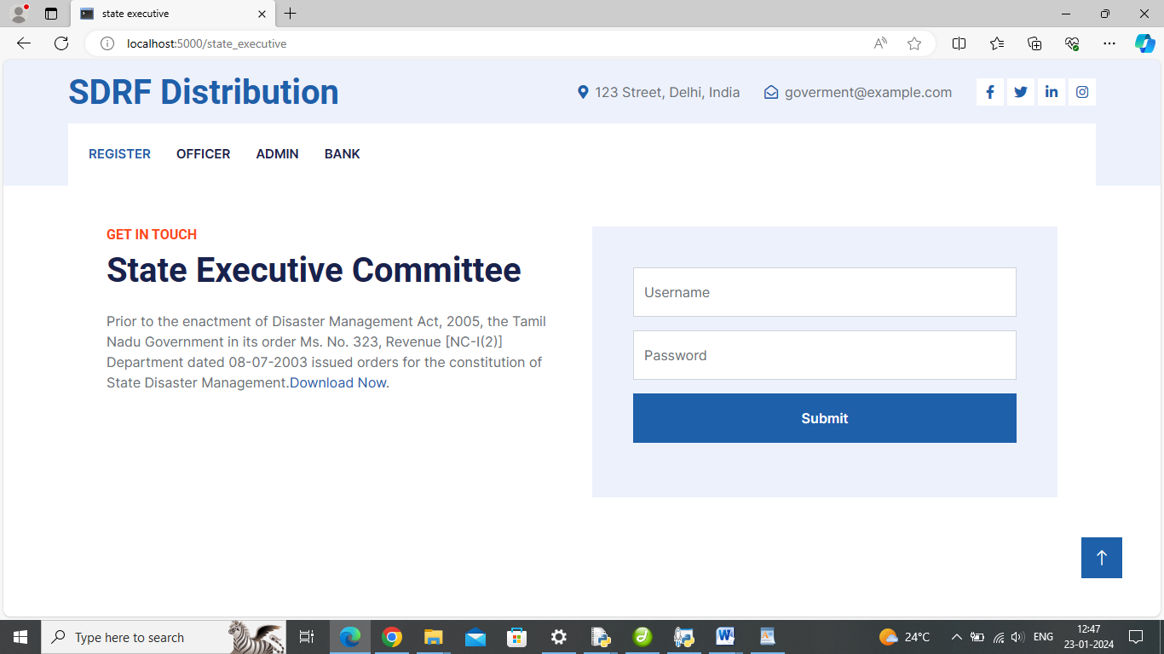

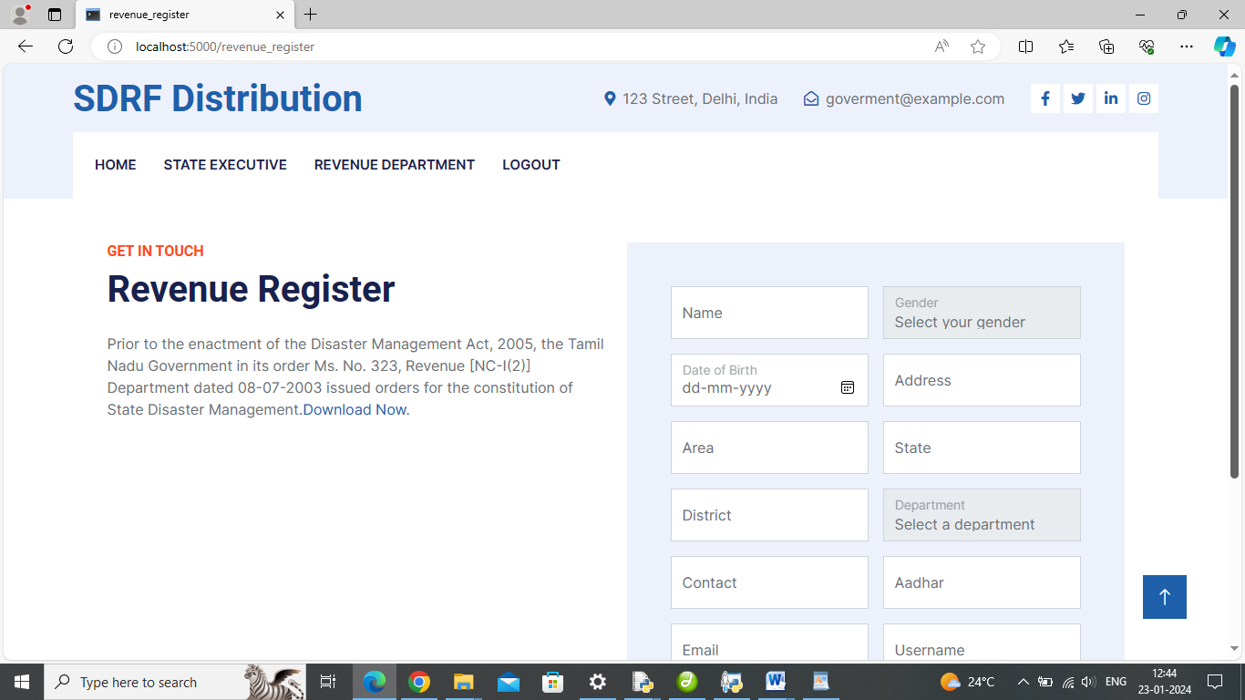

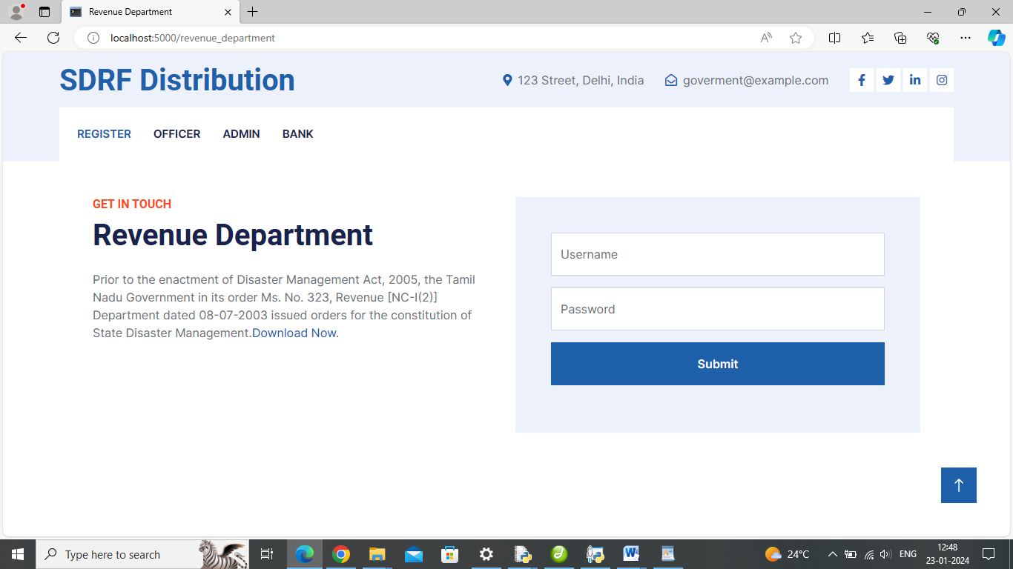

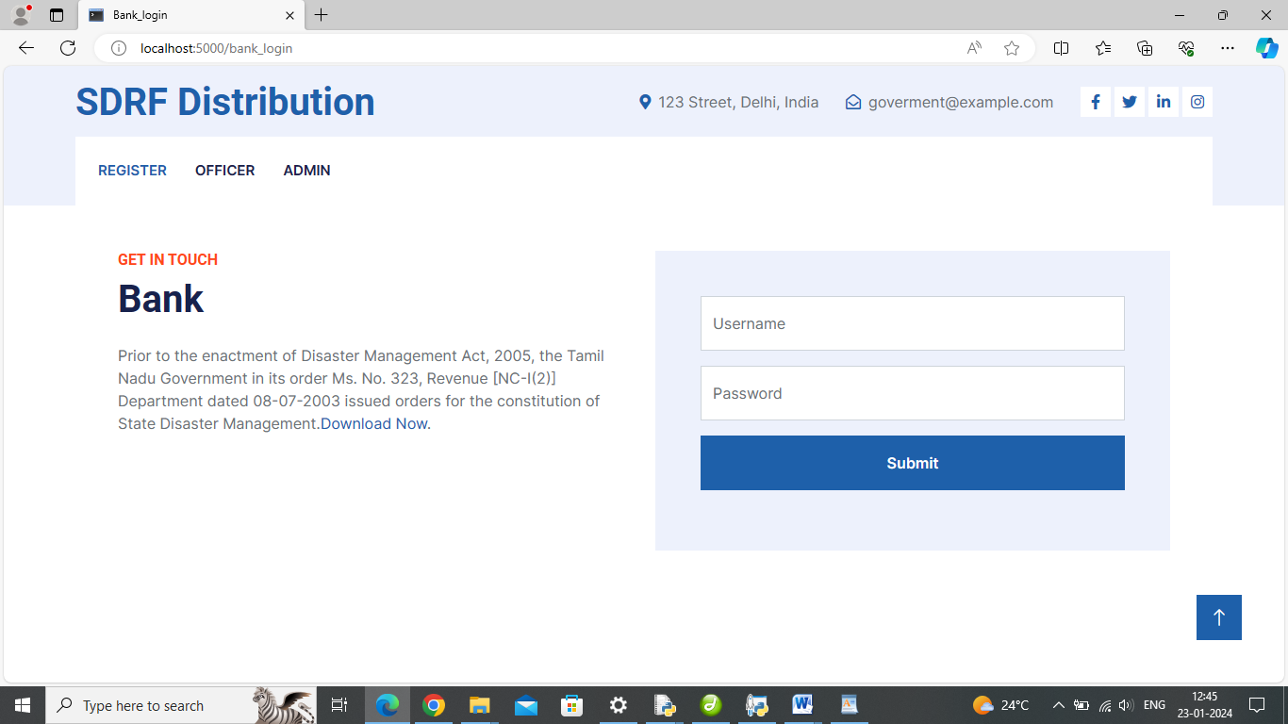

**8.2. SOURCE CODE**

**Packages**

from flask import Flask, render_template, Response, redirect, request, session, abort, url_for

import os

import time

from random import randint

import pandas as pd

import numpy as np

import mysql.connector

import urllib.request

@app.route('/', methods=['GET', 'POST'])

def index():

msg = ""

return render_template('index.html')

**Aadhar Verification**

@app.route('/aadhar', methods=['GET', 'POST'])

def aadhar():

msg = ''

if request.method == 'POST':

username = request.form['aadhar']

password = request.form['mobile']

if len(username) != 12 or not username.isdigit() or len(password) != 10 or not password.isdigit():

msg = 'Invalid Aadhar or mobile number!'

return render_template('aadhar.html', msg=msg)

otp = str(random.randint(100000, 999999))

session['aadhar'] = username

session['mobile'] = password

session['otp'] = otp

return redirect(url_for('otp'))

return render_template('aadhar.html')

**Check OTP**

def otp():

msg = ""

key = ""

if 'aadhar' in session:

aadhar = session['aadhar']

cursor = mydb.cursor()

cursor.execute('SELECT * aadhar WHERE aadhar = %s', (aadhar, ))

account = cursor.fetchone()

if account:

key = str(account[0])

if request.method == 'POST':

entered_otp = request.form['otp']

if entered_otp == key:

session['aadhar'] = aadhar

return redirect(url_for('verify_aadhar'))

else:

msg = 'Incorrect OTP!'

return render_template('otp.html', msg=msg, key=key)

**User Register**

def register_user():

msg = ""

if request.method == 'POST':

name = request.form['name']

gender = request.form['gender']

dob = request.form['dob']

address = request.form['address']

area = request.form['area']

taluk = request.form['taluk']

state = request.form['state']

district = request.form['district']

pincode = request.form['pincode']

contact = request.form['contact']

aadhar = request.form['aadhar']

email = request.form['email']

bank = request.form['bank']

branch = request.form['branch']

input_account = request.form['account']

ifsc = request.form['ifsc']

uname = request.form['uname']

password = request.form['pass']

cursor = mydb.cursor()

cursor.execute('SELECT * FROM user WHERE name = %s', (name,))

existing_account = cursor.fetchone()

if not existing_account:

cursor.execute('INSERT INTO user (name, gender, dob, address, area, taluk, state, district, pincode, contact, aadhar, email, bank, branch, account, ifsc, uname, pass) VALUES (%s, %s, %s, %s, %s, %s, %s, %s, %s, %s, %s, %s, %s, %s, %s, %s, %s, %s)',

(name, gender, dob, address, area, taluk, state, district, pincode, contact, aadhar, email, bank, branch, input_account, ifsc, uname, password))

mydb.commit()

msg = 'You have successfully registered!'

return redirect(url_for('user_login'))

else:

msg = 'User with that name already exists.'

cursor.close()

return render_template('register_user.html', msg=msg)

**Login**

def user_login():

msg = ''

if request.method == 'POST':

uname = request.form['uname']

pwd = request.form['pass']

cursor = mydb.cursor()

cursor.execute('SELECT * FROM user WHERE uname = %s AND pass = %s', (uname, pwd))

account = cursor.fetchone()

if account:

session['uname'] = uname

msg = 'Logged in successfully!'

return redirect(url_for('user_dashboard'))

else:

msg = 'Incorrect uname / pass!'

return render_template('user_login.html', msg=msg)

@app.route('/user_dashboard', methods=['GET', 'POST'])

def user_dashboard():

#name = request.form['name']

cursor = mydb.cursor(dictionary=True)

cursor.execute('SELECT * FROM user')

user_details = cursor.fetchall()

return render_template('user_dashboard.html', user_details=user_details)

**Fund Apply**

def fund_apply():

msg = ""

mycursor = mydb.cursor(buffered=True)

if request.method == 'POST':

disasters = request.form['disasters']

name = request.form['name']

gender = request.form['gender']

dob = request.form['dob']

address = request.form['address']

area = request.form['area']

taluk = request.form['taluk']

state = request.form['state']

district = request.form['district']

pincode = request.form['pincode']

contact = request.form['contact']

aadhar = request.form['aadhar']

email = request.form['email']

bank = request.form['bank']

branch = request.form['branch']

account = request.form['account']

ifsc = request.form['ifsc']

animal1 = request.form['animal1']

properties = request.form['properties']

total = request.form['total']

file = request.files['file']

mycursor.execute("SELECT max(id)+1 FROM application")

maxid = mycursor.fetchone()[0]

if maxid is None:

maxid = 1

if file.filename == '':

flash('No selected file')

return redirect(request.url)

if file.filename != '':

fn = file.filename

fimg = "F" + str(maxid) + fn

file_path = os.path.join("static/album", fimg)

file.save(file_path)

mycursor.execute('INSERT INTO application (disasters, name, gender, dob, address, area, taluk, state, district, pincode, contact, aadhar, email, bank, branch, account, ifsc, animal1, properties, total, photo) VALUES (%s, %s, %s, %s, %s, %s, %s, %s, %s, %s, %s, %s, %s, %s, %s, %s, %s, %s, %s, %s, %s)',

(disasters, name, gender, dob, address, area, taluk, state, district, pincode, contact, aadhar, email, bank, branch, account, ifsc, animal1, properties, total, fimg))

mydb.commit()

msg = 'Application submitted successfully.'

return redirect(url_for('status'))

return render_template('fund_apply.html', msg=msg)

**Disaster Fund Status**

@app.route('/status', methods=['GET', 'POST'])

def status():

#name = request.form['name']

cursor = mydb.cursor(dictionary=True)

cursor.execute('SELECT * FROM application')

user_details = cursor.fetchall()

return render_template('status.html', user_details=user_details)

**Send Feedback**

feedback_list = []

@app.route('/feedback', methods=['GET', 'POST'])

def feedback():

msg = ''

if request.method == 'POST':

user_feedback = request.form.get('feedback')

if user_feedback:

cursor = mydb.cursor()

query = "INSERT INTO feedback (uname, comment, rdate) VALUES (%s, %s, NOW())"

values = ('username', user_feedback)

cursor.execute(query, values)

mydb.commit()

msg = 'Thank you for your feedback!'

else:

msg = 'Please provide feedback before submitting.'

return render_template('feedback.html', msg=msg)

**CHAPTER 9**

**CONCLUSION AND FUTURE ENHANCEMENT**

**9.1. CONCLUSION**

In conclusion, the proposed system presents a solution to address the challenges associated with the allocation and distribution of State Disaster Relief Funds during natural disasters. By leveraging established technologies such as Python, Flask, MySQL, and Bootstrap, the system aims to streamline operations, enhance transparency, and improve overall efficiency in the management of disaster relief efforts. The system's user-centric design caters to various stakeholders, including citizens, review committees, state executive committees, treasury departments, financial agencies, and disaster management authorities. The clear and intuitive interfaces enable citizens to easily apply for relief funds, track their applications, and receive timely notifications, while government officials can efficiently review, assess, and approve applications through a systematic process. Real-time updates, multi-channel notifications, and customizable reports contribute to effective communication and data-driven decision-making. The feasibility study underscores the technical, operational, economic, legal, scheduling, and social viability of the project. The combination of these factors positions the Disaster Relief Tracker as a practical and beneficial tool for optimizing the disaster relief fund distribution process. Ultimately, this project aligns with the goal of improving disaster preparedness and response, fostering public trust through transparency, and ensuring that relief funds are allocated based on actual needs. By addressing the complexities associated with disaster management, the Disaster Relief Tracker stands as a valuable asset in promoting efficient, equitable, and timely assistance to communities affected by natural disasters.

**9.2. FUTURE ENHANCEMENT**

The propose system plays the foundation for an evolving and adaptive system that can incorporate advancements and expansions in the future. The project's future scope includes:

* **Integration with Emerging Technologies:** Embrace emerging technologies such as artificial intelligence (AI) and machine learning (ML) to enhance the system's capabilities. These technologies can be utilized for predictive analytics, pattern recognition, and improving decision-making processes.
* **Enhanced GIS Functionality:** Further develop the GIS mapping features to provide more detailed and real-time information on disaster-affected areas. Integration with advanced mapping technologies can offer precise geospatial data for better decision support.
* **Mobile Application:** Develop a dedicated mobile application to make the system more accessible to citizens and officials, allowing them to interact with the platform on smartphones and tablets.
* **Blockchain for Transparency:** Explore the integration of blockchain technology to enhance transparency, security, and immutability in the fund allocation and distribution process. Blockchain can provide a tamper-proof ledger of transactions.

By continually evolving and incorporating these future enhancements, the system can play a pivotal role in shaping the landscape of disaster management, response, and recovery on both a local and global scale.

**CHAPTER 10**

**BIBLIOGRAPHY**

**10.1. REFERENCE**

### [Harnessing Twitter and Instagram for disaster management](https://ieeexplore.ieee.org/document/8167723/) [W. Sherchan](https://ieeexplore.ieee.org/author/37545885800);[S. Pervin](https://ieeexplore.ieee.org/author/37086619238);[C. J. Butler](https://ieeexplore.ieee.org/author/37089121722);[J. C. Lai](https://ieeexplore.ieee.org/author/37086619515);[L. Ghahremanlou](https://ieeexplore.ieee.org/author/37086620461);[B. Han](https://ieeexplore.ieee.org/author/37086619615) [IBM Journal of Research and Development](https://ieeexplore.ieee.org/xpl/RecentIssue.jsp?punumber=5288520)

Year: 2017

1. [Eyes Move, Drones Move Explore the Feasibility of Various Eye Movement Control Intelligent Drones](https://ieeexplore.ieee.org/document/9650336/) [Yizhou Zhou](https://ieeexplore.ieee.org/author/37089209001) [2021 IEEE International Conference on Data Science and Computer Application (ICDSCA)](https://ieeexplore.ieee.org/xpl/conhome/9649650/proceeding) Year: 2021

### [Application of UICT for the Proactive Management of Emergency Situation and Transport safety](https://ieeexplore.ieee.org/document/9004232/) [Sreedhanya M V](https://ieeexplore.ieee.org/author/37088072641) [2019 International Conference on Computational Intelligence and Knowledge Economy (ICCIKE)](https://ieeexplore.ieee.org/xpl/conhome/8976368/proceeding) Year: 2019

### [Backpack Energy Harvesting System With Maximum Power Point Tracking Capability](https://ieeexplore.ieee.org/document/9339941/)

[Luigi Costanzo](https://ieeexplore.ieee.org/author/37085348367);[Mingyi Liu](https://ieeexplore.ieee.org/author/37088984145);[Alessandro Lo Schiavo](https://ieeexplore.ieee.org/author/37398116200);[Massimo Vitelli](https://ieeexplore.ieee.org/author/37275811000);[Lei Zuo](https://ieeexplore.ieee.org/author/37085772222)

[IEEE Transactions on Industrial Electronics](https://ieeexplore.ieee.org/xpl/RecentIssue.jsp?punumber=41) Year: 2022

### [Functional Requirements Synthesis in Creation of Modular UAV Multisensory System Payload for Mountain Snow Search and Rescue Missions](https://ieeexplore.ieee.org/document/9438883/) [Aleksey Russkin](https://ieeexplore.ieee.org/author/37088871041);[Maksim Alekhin](https://ieeexplore.ieee.org/author/37086437625);[Anastasia Iskhakova](https://ieeexplore.ieee.org/author/37086267804) [2021 International Siberian Conference on Control and Communications (SIBCON)](https://ieeexplore.ieee.org/xpl/conhome/9438828/proceeding) Year: 2021

**10.2. BOOK REFERENCES**

## "Python Crash Course" by Eric Matthes

## "Flask Web Development: Developing Web Applications with Python" by Miguel Grinberg

## "WampServer 2.0" by Jean-Claude et Dominique Lefort

## "Deep Learning with Python" by François Chollet

## "Hands-On Machine Learning with Scikit-Learn, Keras, and TensorFlow" by Aurélien Géron

## "Learning MySQL" by Seyed M.M. (Saied) Tahaghoghi and Hugh E. Williams

## "Bootstrap 4 Quick Start: A Beginner's Guide to Building Responsive Layouts with Bootstrap 4" by Jacob Lett

1. "Automate the Boring Stuff with Python: Practical Programming for Total Beginners" by Al Sweigart
2. "Flask Framework Cookbook: Over 80 proven recipes and techniques for Python web development with Flask" by Shalabh Aggarwal
3. "MySQL Cookbook: Solutions for Database Developers and Administrators" by Paul DuBois
4. "Bootstrap 4 in Action" by Silvio Moreto

**10.3. WEB REFERENCES**

1. Official Python Documentation: https://docs.python.org
2. Real Python (Tutorials and Articles): https://realpython.com
3. Flask Documentation: https://flask.palletsprojects.com
4. Flask Tutorial by Corey Schafer: <https://www.youtube.com/playlist>
5. WampServer Official Website: http://www.wampserver.com
6. WampServer Tutorial: https://www.javatpoint.com/install-wamp-server
7. Keras Documentation: https://keras.io
8. Keras GitHub Repository: https://github.com/keras-team/keras
9. TensorFlow Official Website: https://www.tensorflow.org
10. MySQL Documentation: https://dev.mysql.com/doc
11. Bootstrap Documentation: https://getbootstrap.com/docs
12. Bootstrap Tutorial by W3Schools: https://www.w3schools.com/bootstrap